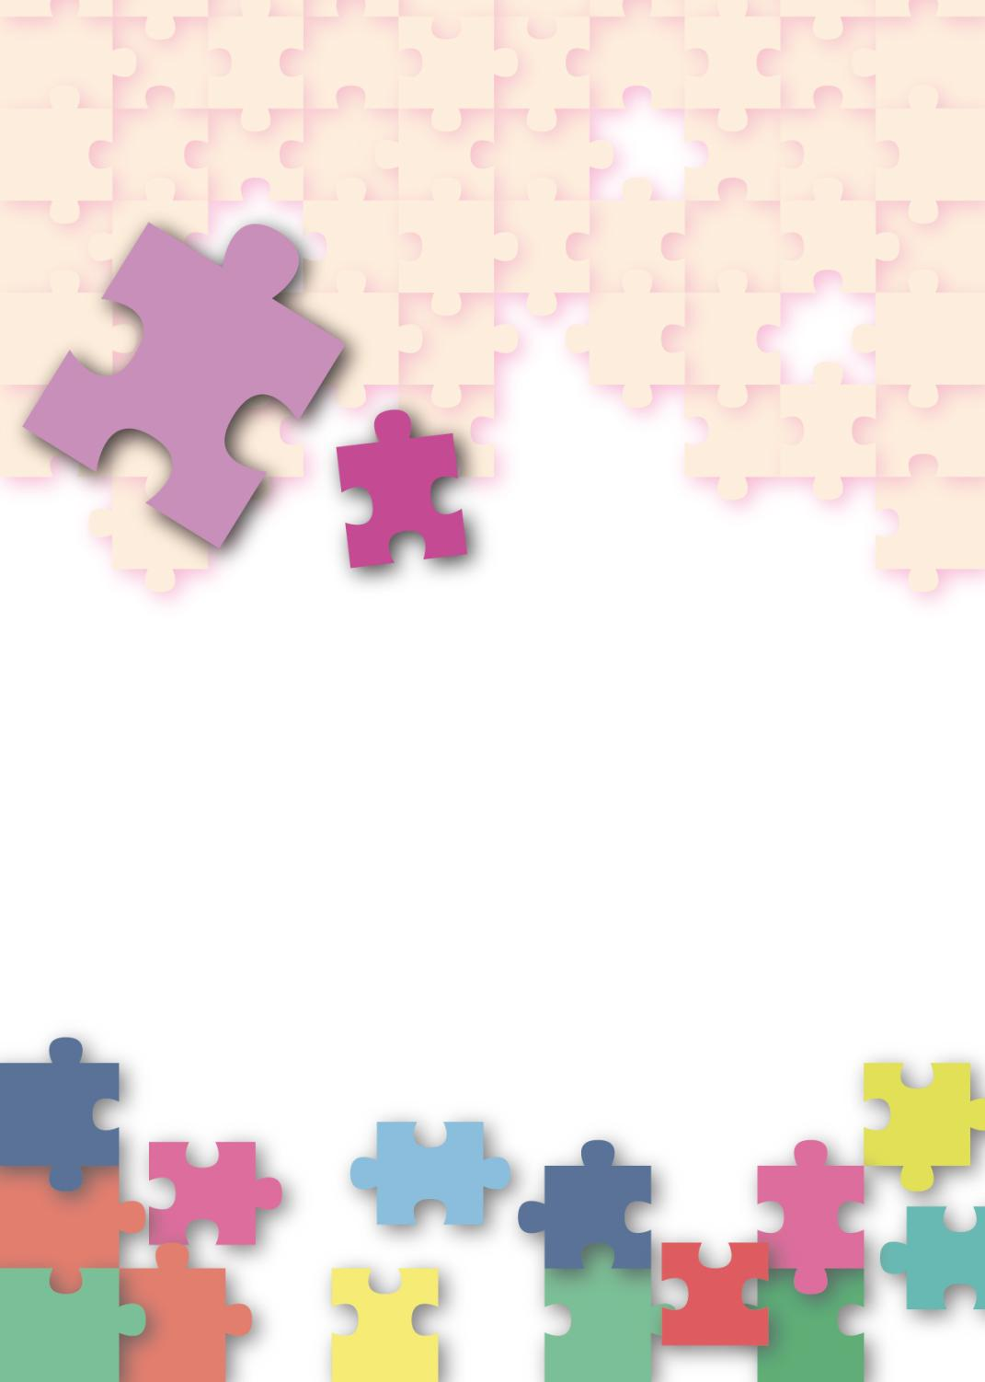
Citizenship, Economics and Society
(Secondary 1-3)
Support Resources
Secondary 2




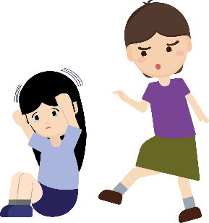
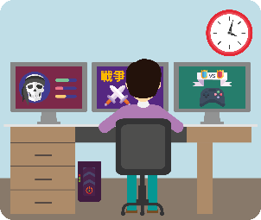

Module 2.1:
Overcoming Growth Challenges
Personal, Social and Humanities Education Section
Curriculum Development Institute
Education Bureau
Introduction

- The “Citizenship, Economics and Society (Secondary1-3) Support Resources” covers the essential learning contents of Strands 1, 5 and 6 in the Personal, Social and Humanities Education Key Learning Area. It is designed to support the implementation of the Citizenship, Economics and Society curriculum.
- The support resources provide diversified learning activities to help students acquire knowledge and understand concepts, develop skills and nurture positive values and attitudes. In addition, they offer teaching guidelines and suggestions on learning and teaching activities for teachers’ reference. Further, they provide reading materials to enhance students’ interest in reading.
- “Module 2.1: Overcoming Growth Challenges” for Secondary 2 was developed by the School of Education and Languages of the Open University of Hong Kong, commissioned by the Personal, Social and Humanities Education Section, Curriculum Development Institute of the Education Bureau.

Module 2.1: Overcoming Growth Challenges

Contents

 | Pages
Teaching Design
Lesson 1 and Lesson 2 | 4
Lesson 3 to Lesson 5 | 7
Lesson 6 | 10
Lesson 7 | 13
Learning and Teaching Activities
Worksheet 1: Develop a healthy lifestyle and positive thinking and lead a rich and fulfilling life | 16
Worksheet 2: Adolescents and undesirable behaviours | 23
Worksheet 3: Causes and negative effects of undesirable behaviours among adolescents | 48
Worksheet 4: Strategies to prevent undesirable behaviours in adolescents and help them return to the right path | 72
Enquiry learning worksheet | 79
Appendix 1: Joyful Reading
Face and overcome difficulties positively | 113
References | 114

Teaching Design:
Topic: | Overcoming Growth Challenges and Rejecting Undesirable Behaviours
Duration: | 7 lessons
Learning objectives: | - To recognise the importance of having a healthy lifestyle and positive thinking to help adolescents overcome growth challenges and lead a rich and fulfilling life  - Undesirable behaviours of adolescents include bullying, sexual harassment, drug abuse, smoking, gambling, internet addiction, pornography addiction, compensated dating, naked chat, etc.  - To recognise the causes why adolescents incautiously acquire undesirable behaviours (including escaping from reality, satisfying various desires, etc.)  - To understand the impacts of undesirable behaviours on adolescents (including the negative impacts on personal prospects and legal consequences)  - To grasp the strategies which prevent undesirable behaviours in adolescents and help them return to the right path
Lesson 1 and Lesson 2
Pre-lesson preparation; | Students shall finish the following before class:  - Students study Worksheet 1 and 2 and complete the activities.
 |  | Suggested lesson time
Enquiry process: | - Set: The teacher briefly introduces the content of Worksheet 1 “Develop a healthy lifestyle and positive thinking and lead a rich and fulfilling life”, and helps students prepare for the study of this topic. | 5 minutes
Enquiry process: | - Interactive teaching:  - Direct instruction: The teacher briefly introduces “Content knowledge 1: What is a healthy lifestyle?” in Worksheet 1.  - The teacher invites students to share examples and personal experiences of healthy lifestyles and guide students to think about the significance of developing a healthy lifestyle, and to understand the importance and the impacts of positive thinking on themselves.  - Video playing: Activity 1: The teacher plays the video “Hong Kong Spirit Ambassador 2013: Li Yip-fuk” and leads a class discussion with students, so that they understand how positive thinking can help and influence their life, and learn how to build a rich and fulfilling life. | 15 minutes
Enquiry process: | - Pair work:  - Students work in pairs to discuss and share thoughts based on “Activity 2: My positive thinking” in Worksheet 1. The teacher invites several groups of students to share their discussion results.  - The teacher may refer to Appendix 1 “Know more: Positive life” and Appendix 2 “Know more: Learn to think positive”. By understanding the concepts of “positive psychology” and “irrational beliefs”, the teacher deepens students’ understanding of how to practise positive thinking in daily life. | 20 minutes
Enquiry process: | - Interactive teaching:  - Direct instruction: The teacher introduces Worksheet 2 “Adolescents and undesirable behaviours” and guides students to understand the universality of undesirable behaviours and how they affect our lives.  - Group competition: Students form groups of four to five and compete to finish Worksheet 2 “Activity 1: Tracking undesirable behaviours”. Each group finds out the words related to undesirable behaviours as soon as possible and then check the answers.  - Class discussion: The teacher invites students to share their answers in Worksheet 2 “Activity 1: Tracking undesirable behaviours”.  - Summary: The teacher reminds students to learn more about undesirable behaviours and their negative consequences, and to face them with caution. |  | 15 minutes
Enquiry process: | - Interactive teaching:  - Direct instruction: The teacher introduces “Content knowledge 1: Common undesirable behaviours among adolescents”.  - Group discussion: Students form groups of four and complete “Activity 2-11”, so as to have a better understanding of undesirable behaviours and eliminate misunderstanding.  - Group presentation: The teacher invites each group to report their discussion results.* Based on the discussion results, and questions raised and feedback given by the teacher and peer students, the teacher helps students deepen their understanding of the types and characteristics of undesirable behaviours.  * The teacher can also learn about students’ choices by means of Socrative or show of hands. |  | 15 minutes
Enquiry process: | - Conclusion:  - The teacher summarises the main learning objective of the lesson, which is to help students develop a healthy lifestyle and positive thinking and lead a rich and fulfilling life, and informs students of the danger and complexity of undesirable behaviours, so that they know how to reject such behaviours.  - The teacher encourages students to check if they have developed some undesirable behaviours/habits and asks them to reflect on the following:  - Have I acquired any undesirable behaviours? If yes, what are the causes of my undesirable behaviours? If no, what strategies should I take to prevent myself from acquiring undesirable behaviours? |  | 10 minutes
Extended Learning Activity: | Students read Appendix 1 “Know more: Positive life”, Appendix 2 “Know more: Learn to think positive” and Appendix 3 “Know more: Classification of Internet addiction” after class and reflect on the content.
Learning and Teaching Resources: | Worksheets 1-2; Appendices 1-3

Lesson 3 to Lesson 5
Pre-lesson Preparation: | Students shall finish the following before class:  - Read Worksheet 3 and Worksheet 4 and complete the activities.
 |  | Suggested lesson time
Enquiry Process: | - Set and revision: The teacher briefly reviews the key learning points in Lessons 1 and Lesson 2 with students. | 5 minutes
Enquiry Process: | - Interactive teaching:  - Direct instruction: The teacher briefly introduces Worksheet 3 “Causes and negative effects of undesirable behaviours among adolescents”.  - Teacher explanation:  - The teacher explains Worksheet 3 “Content Knowledge 1: Bullying”, student will understand more about types and forms of bullying, people involved in bullying, the characteristics of the bully and the bullied, as well as the negative effects of bullying.  - Group discussion: Students form groups of four to analyse the case in Activity 1 and complete the discussion questions.  - Presentation and class discussion: The teacher invites the groups to report their discussion results. Based on the presentation and questions raised by and feedback given by teacher and peers, the teacher guides students to understand the causes and effects of bullying. | 25 minutes
Enquiry Process: | - Interactive teaching:  - Direct instruction: The teacher briefly introduces the content of Worksheet 3 “Content knowledge 2: Sexual harassment” in Worksheet 3. The teacher discusses with the class the reasons for sexual harassment in adolescents and explain the nature of sexual harassment with common examples provided by the Equal Opportunities Commission*.  *The teacher can play the sex education animation “Intimacy Boundary” to help students understand the types and examples of sexual harassment.  - Class discussion: Students complete Activity 2 “Quiz about sexual harassment” in Worksheet 3. The teacher invites students to report their discussion results, and to vote on Socrative anonymously or with pseudonyms to see which questions are selected by more students. Alternatively, the teachers can invite students to share the reasons for their choices. | 20 minutes
Enquiry Process: | - Interactive teaching:  - Direct instruction: The teacher explains “Negative effects of sexual harassments on the victims” and guides students to understand the severity of sexual harassment and its impact on the victims.  - Group discussion: Students form groups of four to analyse the case in Activity 3 and complete the discussion questions.  - Presentation and class discussion: The teacher invites the groups to report their discussion results. Based on the discussion results and the questions raised by and feedback given by the teacher and peers, the teacher deepens students’ understanding of the causes and effects of sexual harassment.  - Student reflection: With the use of the information on the consequences and severity of and penalties for illegal behaviours in Appendices 4 and 5, the teacher guides students to understand the serious consequences and negative effects of undesirable behaviours. The teacher asks students to reflect on the correct attitudes when facing undesirable behaviours. | 25 minutes
Enquiry Process: | - Interactive teaching:  - Direct instruction: The teacher briefly introduces “Content Knowledge 3: negative effects of drug abuse”.  - Group discussion: Students form groups of four to analyse the case in Activity 3 and complete the discussion questions.  - Presentation and class discussion: The teacher invites the groups to report their discussion results. Based on the presentation and questions raised by and feedback given by the teacher and peers, the teacher guides students to understand the causes and effects of drug abuse. | 25 minutes
Enquiry Process: | - Summary:  - The teacher summarises the key learning points of this lesson: “causes and effects of undesirable behaviours”.  The teacher encourages students to improve their awareness of and ability to cope with undesirable behaviours, as well as to develop positive values and attitudes. | 5 minutes
Enquiry Process: | 7. Interactive teaching:  - Direct instruction: The teacher briefly introduces Worksheet 4 “Strategies to prevent undesirable behaviours in adolescents and help them return to the right path”. Teacher talks about “Content Knowledge 1: Strategies to prevent undesirable behaviours” and “Content Knowledge 2: Strategies to return to the right path.”  - Group discussion: Students form groups of four to analyse the case in Activity 1 in Worksheet 4, and complete the questions, based on the strategies for preventing undesirable behaviours in adolescents and helping them return to the right path.  - Presentation and class discussion: The teacher invites the groups to report their discussion results. Based on the presentation, and the questions raised by and feedback given by the teacher and peers, teacher deepens students’ understanding and application of the strategies for preventing undesirable behaviours.  - Summary: The teacher summarises the strategies for preventing undesirable behaviours and strategies for helping adolescents return to the right path, as well as suggestions from students. | 15 minutes
Extended Learning Activity: | Students read Appendix 4 “Know more: Consequences and severity of juvenile delinquency” and Appendix 5 “Know more: Consequences of and penalties for undesirable behaviours” after class.
Learning and Teaching Resources: | Worksheet 3 and 4; Appendix 4-5

Lesson 6
Pre-lesson Preparation: | Students shall finish the following before class:  Read case study activity worksheet and complete the activities.
 |  | Suggested lesson time
Enquiry Process: | - Set and revision: The teacher briefly reviews the key learning points in Lessons 3-5, including the features, reasons and consequences of undesirable behaviours. | 5 minutes
 | - Interactive teaching:  - Briefing on the case study activity: Students are divided into groups of four students. The teacher briefly introduces the case study activity involving 9 common adolescents’ undesirable behaviours (including drug abuse, smoking, gambling, internet addiction, addicted to pornography, bullying, sexual harassment, compensated dating and naked chat). Teacher divides the above undesirable behaviours into two categories: Category A “addictive behaviours” (including drug abuse, smoking, gambling, internet addiction, addicted to pornography) and Category B “undesirable behaviours” (including bullying, sexual harassment, compensated dating and naked chat). Each group will be assigned to work on two cases of addictive behaviours or two cases of undesirable behaviours. (Teacher can assign 2 cases out of the 5 cases of addictive behaviours, or 2 cases out of the 4 cases of desirable behaviours to each group. All assigned cases share common features.)  - Group discussion:  Category A “addictive behaviours”  - Students in each group read the assigned cases first, and then discuss and fill in the worksheets on the background features of the addictive behaviours, behavioural features, consequences, and methods of rejecting the addictive behaviours and strategies to return to the right path. Then they find the common and different background features, behavioural features, etc. of the two addictive behaviours. After the study and discussion, students report to the class.  * Cater for learner diversity: The teachers can moderate the task demands according to students’ abilities. For the less abled students, teacher can provide students with choices (e.g. keywords bolded) to complete the fill-in-the-blank questions. For the part of the worksheet on the methods to reject the addictive behaviours and strategies to return to the right path, for more abled students, they can directly extract the strategies from the reading source and make suggestions on solutions based on materials collected from online sources.  Category B “undesirable behaviour”  - Students read the assigned cases first, and then discuss and fill in the reasons of acquiring the undesirable behaviour, negative impacts on self and others, the right way of getting satisfaction, and strategies to return to the right path. The teacher needs to guide students to find out common and uncommon reasons of acquiring the undesirable behaviours  - Group presentation and whole-class discussion: Invite Category A “addictive behaviour” groups to present the discussion results. Through listening to discussion results of different groups, the teachers’ and peers’ questioning and feedback, students deepen their understanding of the strategies of tackling addictive behaviours.  - Summary: The teacher summarises the preventive methods and strategies to return to the right path and suggestions provided by students as consolidation. Groups that are responsible for “undesirable behaviours” will do presentation in next lesson. | 35 minutes
Extended Learning activity: | Students read Appendix 6 “Joyful Reading: Face and overcome difficulties positively” after class and reflect on relevant issues.
Learning and Teaching Resources: | Case study activity worksheets; Appendix 6

Lesson 7
Pre-lesson Preparation: | Students shall finish the following before class:  Read case study activity worksheets and complete the activities.
 |  | Suggested lesson time
Enquiry Process: | - Set and revision: The teacher briefly reviews the key learning points of addictive behaviours in Lesson 6, including features of addictive behaviours, negative impacts on self and others, the right way of getting satisfaction, and strategies to return to the right path. | 5 minutes
 | - Interactive teaching:  - Group presentation and whole-class discussion: Invite each group to present the discussion results. Through listening to discussion results of different groups, teachers’ and peers’ questioning and feedback, students deepen their understanding of the strategies of tackling undesirable behaviours.  - Summary: Summarise preventive methods and strategies to return to the right path and suggestions by students as consolidation. | 25 minutes
 | - Lesson consolidation:  - The teacher summarises the key learning points of topics of this lesson, including causes and consequences of undesirable behaviours, preventive methods of undesirable behaviours and strategies to return to the right path.  - The teacher can use a summary table to conclude the similarities and differences of background features, behavioural features, consequences of undesirable behaviours, negative impacts on self and on others, preventive methods and strategies to return to the right path. Teacher conveys the following messages:  - A healthy and meaningful lifestyle and optimistic, perseverant, proactive and positive beliefs is important to living a fulfilling life and resisting undesirable behaviours;  - A fulfilling life can be achieved in different ways and everyone can expect and live a fulfilling life;  - Realising one’s potential and striving for one’s goals and well-being of others will lead to a fulfilling life;  - Challenges and setbacks are common in personal growth and one must deal with them with proper attitudes and strategies;  - Turning to undesirable behaviours due to ignorance and weakness will ruin a fulfilling life; and  - Overcoming growth challenges with desirable attitudes and self-management skills is an inevitable stage for transiting from adolescence to adulthood. | 10 minutes
Extended Learning activity: | Students read Appendix 6 “Joyful Reading: Face and overcome difficulties positively” after class and reflect on relevant issues.
Learning and Teaching Resources: | Case study activity worksheets；Appendix 6

Module 2.1: Overcoming Growth Challenges
(Lessons 1 and Lesson 2)
Learning and Teaching Materials
The teacher asks students to finish Worksheets 1 and 2 before class, carries out a class discussion and summarises the discussion results.

Preface
As adolescents grow up, they need to adapt to physical and psychological changes as well as expectations from their families, schools, peers, and even society. If their own ability or experience is not enough to meet the requirements of the change, they may develop undesirable behaviours. Therefore, a healthy lifestyle and positive thinking not only help adolescents stay away from undesirable behaviours, but also play a key role in overcoming growth challenges and enabling adolescents to lead to a rich and fulfilling life.

This Resource discusses how to develop a healthy lifestyle and positive thinking. It analyses causes why adolescents incautiously acquire undesirable behaviours and their impacts on adolescents, as well as the related consequences and even legal responsibilities. It reminds adolescents to stay vigilant, learn to protect themselves, and bravely say “no” to undesirable behaviours.
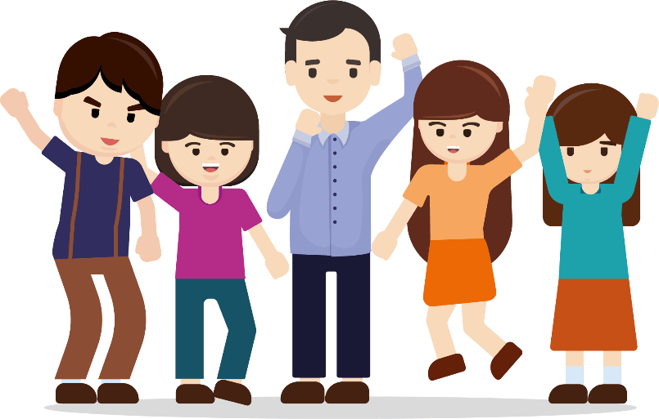
Worksheet 1: Develop a healthy lifestyle and positive thinking and lead a rich and fulfilling life


Content knowledge 1: What is a healthy lifestyle?
According to the World Health Organisation, “Health is a state of complete physical, mental and social well-being and not merely the absence of disease or infirmity.” A healthy lifestyle means adopting healthy habits and quitting undesirable behaviours. Adopting healthy habits include three aspects: “Maintain”, “Practise” and “Refuse”. “Maintain” includes maintaining personal hygiene, regular daily routines and mental health. “Practise” includes regular physical activities and healthy diets. “Refuse” includes saying no to smoking, alcohol and drug-taking. Unhealthy lifestyles and habits increase our risk of illnesses, and also hinder social relationships and mental health. Therefore, we must quit bad lifestyles and habits, such as excessive dieting or lack of sleep, and develop healthy habits as soon as possible. Figure 1 shows the three aspects of a healthy lifestyle.

Figure 1 Healthy lifestyle
Source: Excerpted and adapted from World Health Organisation (1948), WHO definition of health; Student Health Service, Department of Health, the Government of the HKSAR (2020), Healthy living.
Leading a rich and fulfilling life and
The teacher reminds students that the following content was already covered in Learning and Teaching Resources in Secondary 1.
positive thinking
A healthy body and mind and positive thinking are indispensable to a rich and fulfilling life of adolescents. Everyone always has some beliefs in life, guiding their own directions and actions. Beliefs are the inner voice, the views of oneself and others, the attitude towards and the way of dealing with things. John Stuart Mill, the famous British philosopher, psychologist and economist once said, “One person with a belief is equal to ninety-nine who have only interests.” It shows how beliefs can guide us to strive for excellence in life. Positive thinking can even remind us to adjust our thoughts when we feel confused or frustrated, so that we can maximise our potential under any circumstances and move towards a rich and fulfilling life.

Source: Excerpted and adapted from Physical Education Section, Curriculum Development Institute, Education Bureau, the Government of HKSAR (2020), Physical Education (HKDSE).
Translated from Ma Yinchun (2011), Success is achieved by staying grit.《成功是折騰出來的》.

Activity 1: Video watching
Do you know how to build a rich and fulfilling life? Watch the video clip “Hong Kong Spirit Ambassador 2013: Li Yip-fuk” and then answer the following questions.

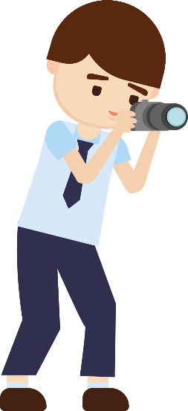
 Hong Kong Spirit Ambassador 2013: Li Yip-fuk
https://youtu.be/29NefJqceg4

Reflective questions:
Answer the following questions based on the video clip:
- What beliefs does the main character in the video have?
He believes that if God closes a door, he will open a window for you; that
you can prove yourself with perseverance even if you were born with
inadequacy; that God treats everyone fairly; that you should work hard
and grasp opportunities instead of losing heart; that you cannot make
progress unless you work harder and do not give up; and that you can
make others happy by sharing your happiness with them.

- How do these beliefs help him in his life?
They help him remain resilient in adversity and stay perseverant. Despite
his physical disability, he still manages to prove himself. Apart from
finding a job, he has made extraordinary achievements in photography.
And he even shares happiness through his works. He encourages others
with his life experience and achieves his dream as well.

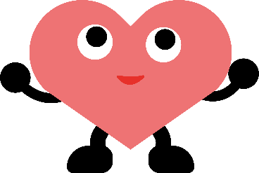


Appendix 1
Know more: Positive life

In Secondary 1, we already covered emotion management skills in Part 1.1 (Part 2) “Emotion Management and Enhancing Resilience”, as well as the Five-Taste Model of Positive Communication in Part 1.2 (Part 1) “Enhancing Family Cohesion”. Both remind us of always using positive thinking in dealing with matters in life and overcome frustrations, so as to make life more valuable and fulfilling.

According to psychologist Martin E. Seligman, one should hold a positive attitude and behave positively to achieve proper psychological balance. Positive thinking has three goals: (1) pleasant life; (2) engaged life; and (3) meaningful life.
Figure 2 Three goals of positive psychology
Source: Excerpted and adapted from Seligman (1998), Learned optimism: How to change your mind and your life (2nd ed.) ; Seligman, Rashid, and Parks (2006) Positive psychotherapy. American Psychologist, 61, 774-788.

We must always keep a cheerful mind, think positive, and broaden our horizons. In addition, we should maintain good health by means of exercise and activities that are beneficial to our body and mind. We should actively contribute to and serve the community. The happiness of life is not only about satisfying personal desires, but also about considering the situations of others and society, so that everyone can live a meaningful life.

Activity 2: My positive thinking
The teacher asks students to review the parts about enhancing positive thinking and reducing negative emotions in Secondary 1 Module 1.1 Self-understanding
And Life Skills (Part 2) “Emotion Management and Enhancing Resilience”.
Recall four unhappy events you experienced, and your negative thoughts at that time. And then rewrite them from the perspective of positive thinking.

Unhappy events | Negative thoughts | Positive thinking
E.g.: I lost points in the basketball game. Our team could not advance as a result. | I am a loser. | Though my performance was not good enough, I had tried my best. I will take this failure as a lesson and keep bettering my skills.
- E.g.: I failed the English quiz this time. | I will need to repeat the grade. | Failing English quiz is just the result of insufficient revision. Next time I will work harder and I will definitely perform better.
- E.g.: My little sister had a stomach-ache today. | I must have failed to take good care of her. | My little sister’s stomach-ache may be caused by many reasons. I will learn about the cause and take good care of her.
- E.g.: In today’s group presentation, the whole class saw that I didn’t know how to operate the projector | Embarrassing things always happen to me. | Though it was a bit embarrassing, I learned how to operate the projector. And it is good for me.
- E.g.: I was not selected for the football team. | As I failed to join the football team, my football dream will never be realised. | I will keep practising and strive for the next chance of being selected for the football team.


Appendix 2
Know more: Learn to think positive
Irrational thoughts
As the saying goes, “That’s the way the cookie crumbles” In fact, when we face them positively, an unhappy event may be only small tests in life, or even the cornerstone of success. However, when faced with unhappy things, some people tend to be occupied by irrational and unreasonable thoughts. Worse still, they may even make improper judgements on the matters. Such thoughts can affect emotions and behaviours, interpersonal dealings and even social life. In the long term, they can compromise physical and mental health. So they are a warning sign that requires attention. Here are some irrational thoughts and examples. We should be aware of their negative impacts and avoid the mistakes.
Irrational beliefs | Examples
  - Black or white: Some people see the world as black or white and oversimplify things. They believe everything is either right or wrong, good or bad. They fail to look at things from different angles. | People who do not do well in school will not do well in life.
  - Catastrophising: Some people amplify the negative side of things. They believe the consequences will be too horrible to bear. They assume the worst of everything. They worry about an imminent disaster all the time. | If I can't get full marks in the exam, I will not be able to enter a prestigious university, and my life will be worthless.
  - Emotional reasoning: Some people cannot analyse things calmly or objectively. They decide on their thoughts based on feelings alone. If they don’t feel right on a single day, they will hold negative thoughts about everything. | In short, I got up in the morning and felt upset. I knew nothing would go well today.
  - Fortune-telling: Some people predict all kinds of dangers in future and believe things will only get worse. | They won’t like me. They won’t accept me. They will reject me or even harm me.
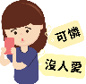  - Labelling: Some people summarise themselves or others with negative labels | I’m a poor and unloved person.
  - Absolute thinking: Some people describe how things will happen based on their emotions instead of the actual real situation. They often use the words “always”, “definitely”, “absolutely” or “must”. | I must get 100 points; otherwise I will be a loser.
  - Overgeneralisation: Some people summarise the whole situation with one negative event. | This happened to me because I was born an unfortunate person.
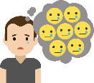  - Focusing on negative information: Some people focus on negative information. But they ignore, understate or misunderstand the good side of things. They do not think positively. They will even play down successful or delightful experience if there is any. | Everyone got a prize. So it’s no big deal for me to get one, let alone a consolation prize that nobody cares.
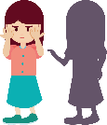  - Self-blaming: Some people blame themselves as the direct or indirect cause for everything bad. Whenever there is a problem, they tend to take the responsibility and believe it is their fault. They ignore the responsibility of others. | It’s my fault that my parents divorced.
Source: Excerpted, adapted and translated from the Nethersole School of Nursing, CUHK (undated), A Psychological Perspective on Campus Bullying ; Wong Ying-ying (2019), Stress Relief Handbook.
Conclusion
Adolescence is a critical period for personal growth and development. Adolescents are faced with physical and psychological changes. Cultivating a healthy lifestyle and positive thinking is the first step in building a rich and fulfilling life and preventing undesirable behaviours.

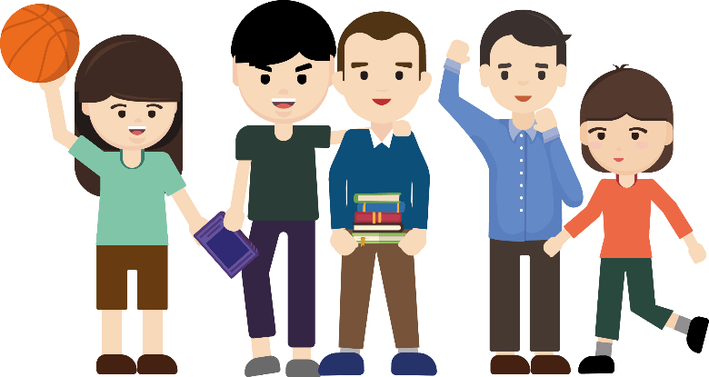
Worksheet 2: Adolescents and undesirable behaviours
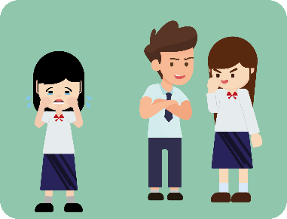
Adolescents are moving from childhood to adulthood. Facing many changes, they must learn how to cope with them to overcome the challenges of growing up. As there are so many things in the journey of growing up, whether adolescents have adequate insights, abilities and will power to resist temptations or identify traps is the key to their growth and future development.

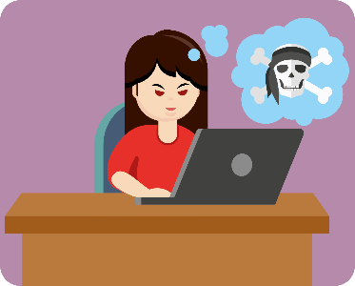
Adolescents are prone to temptations and easily develop undesirable behaviours. During their growth, adolescents face various challenges. They tend to have negative thoughts and emotions when they are under pressure for a prolonged period. If it is not handled properly, they can be easily tempted to develop undesirable behaviours as an escape from distress. But when they get back to reality, they will feel much depressed. In addition, adolescents wish to become adults. In the process they will be affected by factors such as rebelliousness, conformity or temptations in the adult world and easily develop undesirable behaviours. In fact, undesirable behaviours are just a way to deal with matters passively. Engaging in undesirable behaviours cannot really solve the problem. On the contrary, engaging in undesirable behaviours will cause physical and mental effects on oneself, and may also affect one’s family or even the community.

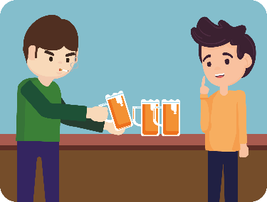
What are undesirable behaviours?
Generally speaking, undesirable behaviours refer to behaviours that are against family, school, or social norms or discipline. There are many specific behaviours, which often have different meanings based on the context, time, and cultural background. If adolescents are being weak-willed or unable to control themselves, they may be lured into undesirable behaviours or even crimes. It will not only affect themselves, but also affect their families and friends and even harm the community, leading to serious consequences. Therefore, we must enhance our understanding of undesirable behaviours to effectively prevent and deal with them and avoid acquiring undesirable behaviours incautiously.
Source: Excerpted, adapted and translated from Yang Guo-shu (1986), The study of the relationships between family factors and adolescents’ behaviours. Chinese Journal of Psychology,28(1),7-28.
Activity 1: Tracking undesirable behaviours
Take a quick glance at the box below. Circle seven other common adolescent undesirable behaviours in addition to sexual harassment and drug-taking.
drug-taking
journalism
class
attention
bullying
Internet addiction

loss
shopping
smoking
laughing
compensated dating

store
sexual harassment
privacy
theft
walking
violence
error
security
pornography addiction

prison
gambling
Naked chat

pornography addiction
Internet addiction compensated dating
naked chat gambling
bullying smoking

1. Common undesirable behaviours among adolescents

There are many types of undesirable behaviours. Common ones among adolescents mainly include bullying, sexual harassment, drug abuse, smoking, gambling, Internet addiction, pornography addiction, compensated dating and naked chat.

Some undesirable behaviours belong to addictive behaviours. Addictive behaviours can be defined as the way in which individuals find themselves unable to stop engaging in the behaviour that is harming them or those whom they care about, even when they try to stop themselves from doing so. Addiction usually includes the three elements below:
Elements of addiction | Characteristics
- Physiological craving | An intense and prolonged desire for a certain substance or behaviour
- Withdrawal symptoms | Exhibiting negative physiological and psychological impacts when trying to reduce or stop the behaviour
- Tolerance | Increasing the amount of substance or the frequency of behaviour to maintain the same level of satisfaction
Source: Excerpted, adapted and translated from Hsu Shao-ling & Shih Hsiang Ju (2013), Is Internet Addiction a Mental Disorder?;Education Bureau of the HKSAR (2016), HMSC Knowledge Enrichment series: HMSC issue, Addiction.

Undesirable behaviours easily engaged by adolescents include:

- Bullying
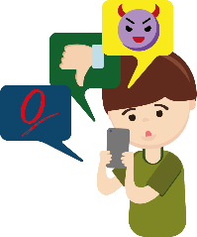
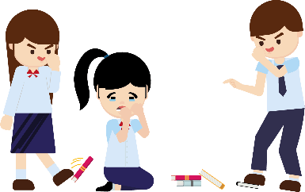
- When adolescents are learning to get along with others, it is inevitable and normal to have disagreements or disputes. However, if the situation turns into an imbalance of power, where the stronger oppresses, harms or causes damages to the weaker, and the situation continues for a prolonged period of time, then it can be regarded as bullying. Common forms of bullying range from physical violence, verbal attacks, to indirect bullying by boycotting and isolation, and to cyber-bullying on online platforms, such as posting insulting messages or threatening content. Some bullies take pleasure in bullying others and damaging others’ belongings, so that the victims suffer obvious negative effects both physically and mentally, such as physical injuries, depression, fear of going to school, insomnia and anxiety.
Source: Excerpted and adapted from Education Bureau of the HKSAR (2020a), Understanding Bullying.
Activity 2: Judge bullying behaviours

Which of the following descriptions are bullying? Put a in the suitable box.

 |  | Bullying | Depends  on the situation
 | Threaten a classmate that if he does not allow me to copy his homework, his secret would be disclosed.
 | Trip a classmate on purpose and cause him/her to fall when he/she is walking along the corridor.
 | Interfere with classmates' ways of expressing themselves, ways of behaving towards others, and ways of doing things.
 | Pull a classmate’s hair in a hostile manner.
 | Persuade friends not to talk to academically weak classmates in the class.
 | Scold a classmate for saying things without thinking.
 | Step on a classmate's textbook on purpose and leave a shoe mark on it.
 | Hold a poll on the blog to give a classmate a silly nickname.
 | Play a trick on a classmate by hiding his mobile phone.
 | In the morning, when you see a classmate you don’t like, you don't say hi to him.

Source of information: Translated from Education Bureau of the HKSAR (2020b), Stop Bullying.

- Sexual harassment
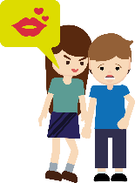
- Sexual harassment is any unwelcome or uninvited sexual behaviour which is generally regarded as offensive, humiliating or intimidating. Acts of sexual harassment include unnecessary physical contact with others, sexual comments and jokes, and staring in a sexual manner.


- Sexual harassment is an unwelcome or unacceptable sexual attention. It can be divided into physical, verbal and non-verbal ones, as well as sexual threats.

- The harasser and the victim of sexual harassment can be anyone, regardless of their gender, age, identity, background, or familiarity with each other. It is not limited to a specific characteristic or gender. Most harassers commit sexual harassment by using their power or peer pressure.

- Sexual harassment is illegal. Harassers shall be held legally responsible for their actions. At the same time, those who knowingly assist others in sexual harassment shall also be held liable.

Source: Excerpted and adapted from Education Bureau of the HKSAR (2015), Prevention of Sexual Harassment in Schools.

Activity 3: Video watching to distinguish sexual harassment

Watch “Intimacy Boundary (Theme: Sexual Harassment among Peers)”, answer the following questions.
“Intimacy Boundary (Theme: Sexual Harassment among Peers)”
https://www.edb.gov.hk/attachment/en/curriculum-development/4-key-tasks/moral-civic/sea/SEA04_Eng_20151203.mp4
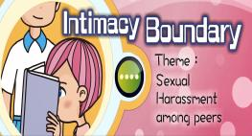

1. | Which part of the following behaviours constitute sexual harassment? Please underline the behaviours that constitute sexual harassment.
a. | Chi Ming and Man Chai call Shan Shan the strange nickname "Baby Shan Shan" and mention that her shyness is very lovely, making her feel terrified so she stays away from them.
 | (Teacher’s reference) Explanation: Giving others unwelcome nicknames and making unwelcome comments on others, which makes people feel offended, are likely to be treated as sexual harassment.
b. | Chi Ming and Man Chai stare at Shan Shan's body strangely, and often comment on her appearance and figure, making her feel embarrassed and uncomfortable.
 | (Teacher’s reference) Explanation: Staring at a person or a person’s body offensively or staring with facial expressions suggesting sexual interest, or making sexually suggestive comments on a person’s body are likely to be treated as sexual harassment.
c. | Chi Ming and Man Chai give Tsz Wai a nickname and tease her that she is dating a male classmate, making her feel angry.
 | (Teacher’s reference) Explanation: Giving others unwelcome nicknames and making unwelcome comments on others, which makes people feel offended, are likely to be treated as sexual harassment.
d. | Tsz Wai teases Chi Ming and Man Chai and calls them "lustful boys", making them feel embarrassed and uncomfortable.
 | (Teacher’s reference) Explanation: Giving others (men or women) unwelcome nicknames (in this case, sexually suggestive nicknames), which makes people feel offended, are likely to be treated as sexual harassment.

Source: Excerpted and adapted from Education Bureau of the HKSAR (2022a), Intimacy Boundary.

- Drug abuse
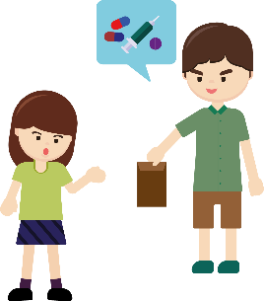
- Drugs bring many harms and serious consequences to adolescents. Drug abuse generally refers to the consumption of mentally hazardous drugs without a doctor’s prescription or guidance, or for non-therapeutic purposes. Common types of drugs include marijuana, ecstasy, cocaine, “ice”, narcotic analgesics, etc. Drug abuse causes physical and psychological dependence. Long-term use also leads to greater dose and frequency. It affects the body’s function and daily life.

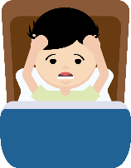
- Drug abuse can cause serious damage to the brain, affecting memory and reaction. It also causes a lot of damage to the mood, appetite, sleep, motor function and other organs of the body. Long-term drug abuse will disrupt the pace of life, affecting one’s relationship with their families and friends. Eventually, one often feels ashamed and blame themselves, which causes more problems.

- Drug abuse among adolescents has always been a concern in the community. Drug abuse and drug abuse crimes are serious crimes. Once convicted, one will be subject to fines and imprisonment. Therefore adolescents should stay on guard and vigilant. In early 2023, the amended Dangerous Drugs Ordinance (Cap. 134) will be implemented to control cannabidiol (CBD). CBD becomes a dangerous drug in Hong Kong, and the manufacture, import, export, supply, sale, possession, etc. of general CBD consumer products will be prohibited. Offenders will face criminal liability if convicted upon prosecution. Members of the public should avoid purchasing or using CBD products now.

Source: Excerpted and adapted from Student Health Service, Department of Health, the Government of the HKSAR (2009), Bridge. Issue no.44. ; Information Services Department, the Government of the HKSAR (2009), 2022 Policy Address; Narcotics Division, the Government of the HKSAR (2022), Key message about Cannabidiol (CBD).

Activity 4: Clarification on drug addiction
Try to clarify the following misconceptions about drugs.

Misconception | Clarification (Suggested answer)
1. Life is short so we have to try taking drugs. It is not easy to get addicted. | Once you have experienced the thrill of taking drugs, it will be hard to resist drugs and will take drugs repeatedly. Therefore, it is easy to get addicted.
2. If drug taking is so problematic, why there are so many people trying it. | That many people try taking drugs doesn’t mean drug taking is not problematic. Taking drugs will cause drug addiction which will bring long-term problems to personal life and society.
3. Drug taking is very trendy. If many classmates try it, why don’t I give it a try too? | Many people do something wrong doesn't make their action right. If you take drugs with bad friends, you will hurt yourself and encourage the growth of the undesirable trend of drug taking.

Source of information: Translated from Education Bureau of the HKSAR (2020c), Say no to drugs.

- Smoking
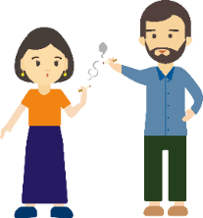
- Smoking generally refers to smoking all types of tobacco, with the more common products being herbal cigarettes, cigars, waterpipe smoking, electronic cigarettes and heated tobacco products. Tobacco contains a variety of substances that are addictive and even cause cancers. It has been proven that heavy and long-term smoking can affect the brain, the heart, the lungs and the mouth. Smokers may even live shorter lives than non-smokers.

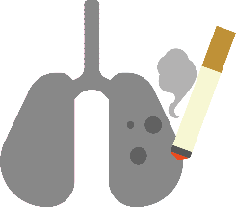
- Apart from being addictive, smoking can also have serious health effects. Lighting a cigarette will release smoke with mixed toxic chemicals to the air, polluting the environment. Besides, the health of non-smokers is harmed by second-hand smoke and become innocent victims.

- Even though the law prohibits retailers from selling tobacco products to minors, some adolescents still try to acquire them by illegal means.

Source: Excerpted and adapted from Student Health Service, Department of Health, the Government of the HKSAR (2005), Bridge. Issue no. 27.

Activity 5: Clarification on smoking

Clarify the following smoking misconceptions.
Misconception | Clarification
- Light smoking will not get me addicted. I can give it a try. |   When most people try smoking tobacco for the first time, they mistakenly think that they will not be controlled by tobacco. In fact, nicotine will make people need more and more tobacco.
- Smoking heated electronic products will not get people addicted. | Heated electronic products are as addictive as conventional cigarettes because they deliver a similar level of nicotine. They can release second-hand smoke.
- Smoking is refreshing and can stimulate thinking. | 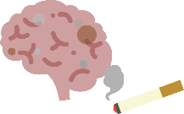  Heavy or long-term smoking can cause brain cell damage, which leads to memory loss and reduced learning and working ability.
- Smoking can help lose weight. | 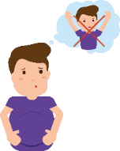  Studies have found that smoking does not help reduce weight. A balanced diet with an appropriate amount of exercise is the direct and effective solution.
- Smoking makes me more attractive. | 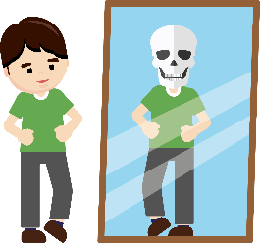  Toxic substances in tobacco will affect the skin, making the skin dull, coarse, less elastic and more sensitive. Tobacco causes eczema and wrinkles and accelerates ageing. Smoking also stains your skin, nails and teeth. And the smoke smells bad. It will damage your personal image.
- Smoking is just cheap entertainment. |   In fact, if you spend 60 dollars a day on tobacco, you will spend more than 20,000 dollars a year.

Source: Excerpted and adapted from Tobacco Control Office, Department of Health, the Government of the HKSAR (2017), To be Stylish or out? It’s up to you smoking and youth; Student Health Service, Department of Health, the Government of the HKSAR (2005), Bridge. Issue no. 27.


5. Gambling
- Gambling generally refers to betting money or something of value, with the intent of winning money by means of luck. When gambling behaviour is out of control and one is unable to deal with the problem and stress caused by gambling, one becomes a pathological gambler. The effects of gambling on adolescents include piling debts, impacts on relationships with family and friends, and even physical and mental distress.

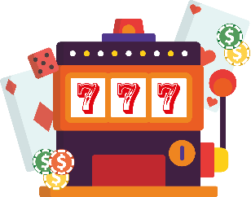
- Common means of gambling in Hong Kong include the Mark Six Lottery, local horse racing betting, e-sports betting, sports betting, etc. With the popularisation of the Internet and mobile Apps, adolescents can now place bets and gamble online or through mobile Apps, instead of through their family members or friends.

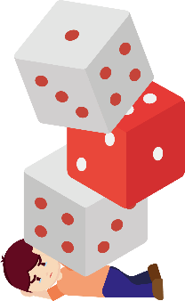
- Addictive gambling can have many negative effects on adolescents, including poor performance in school, health problems, sleep and appetite disorders, inability to concentrate, loss of interest in interpersonal relationships and other things, etc. Some adolescents may even take risks and get money by illegal means to continue gambling or repay their debts.

Source: Excerpted, adapted and translated from The Ping Wo Fund (2017), 2016 report of study on Hong Kong people's participation in gambling activities; The Hong Kong Jockey Club (2020), What is Problem Gambling?.

Activity 6: Judge gambling behaviours

1. Which of the following are gambling? If yes, please put ✔ in the suitable box.

a. During the Lunar New Year, I like playing mah-jong with relatives and friends for entertainment and only a small amount of money is involved. | ✔
b. I bet 20 dollars that Argentina will win over Australia at the World Cup match tonight. | ✔
c. The examination papers will be returned to us soon. I guess our whole class will pass the Chinese subject. If I guess right, you have to give me your newly bought calculator; if I guess wrong, I will give you my newly bought correction tape. Do you dare to bet with me? | ✔
d. My recent hobby is playing roulette at the children’s game centre using tokens or point cards to bet, and the winners will get prizes. | ✔

2. People who view gambling as entertainment often say "gambling involving a small amount of money is entertaining". What do you think is the problem wth this saying?

Suggested answer: Gambling is an undesirable behaviour, no matter it
involves a large or a small amount of money. Gambling will lead to addiction
and brings negative effects to different aspects of life including harm to
mental health. Gambling is not entertaining. Therefore, we should not engage
in undesirable behaviours for entertainment, but stay away from people and
venues that tempt us to gamble, Instead, we should engage in healthy
activities such as exercise for entertainment.

6. Internet addiction
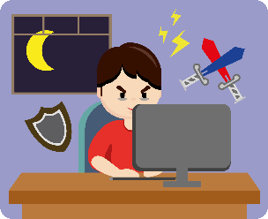
- In the era of rapid Internet development, “phubbing” has become a common social phenomenon. Internet addiction has also become an undesirable behaviour for adolescents. Using the Internet and related products does bring a lot of convenience to our lives. It also enables functions such as communication, learning and entertainment. However, as the time spent on the Internet increases, it is easy to rely on electronic products and become addicted. As a result, one may find it difficult to adapt to the real social life. Some adolescents are under pressure and frustration in reality. Then they unknowingly spend more time online and gradually become addicted, affecting their studies and interpersonal relationships. Common types of Internet addiction among adolescents include online games and online shopping.

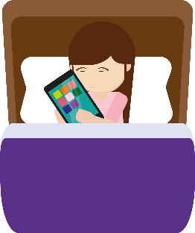
- Long-term addiction to the Internet affects both the body and the mind. In addition to impairing vision, it affects sleep quality and causes muscle soreness and fatigue. Addiction to the Internet and electronic products will reduce face-to-face communication and affect social life. When adolescents become dependent on the Internet, it is difficult for them to reduce and control the time spent. And they will experience withdrawal symptoms such as restlessness, irritability, depression, etc. Worse still, they may even have illusion and gradually become detached from reality, addictive to the virtual world online.

Source: Excerpted and adapted from Department of Health, the Government of the HKSAR (undated), e-report on Healthy Use of Internet and Electronic Screen Products.

Activity 7: The Internet Addiction Test

Fill in the following test items and calculate the score to understand your daily dependency on the use of the Internet.

 | Rarely  1 | Occasionally  2 | Frequently  3 | Often  4 | Always  5
- You find that you stay online longer than you have intended.
- You will neglect work that you need to handle or complete and spend the time on the Internet.
- You will prefer spending time on the Internet to spending time with family and friends.
- You will make new friends on the Internet.
- Your friends or family complain that you spend too much time on the Internet.
- Your grades or school attendance (lateness, early leave or absence) will suffer because of spending time on the Internet.
- You will check your Instagram, WhatsApp, etc, before doing things you need to do.
- Your academic performance or learning effectiveness will suffer because of spending time on the Internet.
- You will become defensive or secretive when people ask you what you are doing online.
- You will make use of the support and comfort received on the Internet to help you forget or stop thinking about the trouble you encounter in life.
- You will look forward to going online again.
- You will worry that life becomes boring, empty and joyless if there is no Internet.
- You will feel annoyed when someone bothers you while you are online.
- You will sleep less at night because of spending time on the Internet.
- You will keep thinking about what you have seen or read on the Internet when you are offline.
- When you are online, you will say to yourself, “I’ll just spend a few more minutes online.”
- You have tried to cut down the amount of time you spend online but fail to do so.
- You will hide from others the amount of time you’ve spent online.
- You will choose to spend time online rather than going out with others.
- You will feel depressed, down or nervous when you are offline, but such feelings just go away when you are back online.
The maximum score is 100 points. Higher scores mean greater severity of Internet addiction.
Total scores that range from 0 to 30 points are considered to reflect a normal level of Internet usage.
Scores of 31 to 49 indicate the presence of a mild level of Internet addiction.
Scores of 50 to 79 indicate the presence of a moderate level of Internet addiction.
Scores of 80 to 100 indicate a severe dependence upon the Internet.

Source: Excerpted and adapted from Tung Wah Groups of Hospital (2022), The Internet Addiction Test; Dr. Kimberly Young (2011), Internet Addiction A Handbook and Guide to Evaluation and Treatment.

7. Pornography addiction
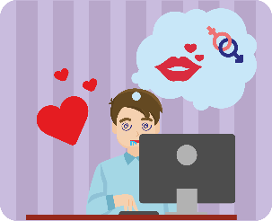
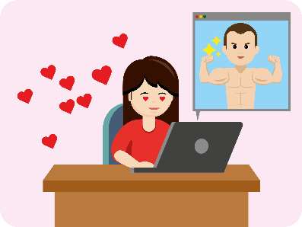
- Pornography addiction refers to indulging in pornographic publications, websites, videos, or even other sex-related behaviours to the point where one cannot control themselves. In their puberty, adolescents are curious about the opposite sex and sexual behaviours, and they try to obtain sex information in different ways. However, pornography is mostly filled with distorted and unhealthy sex information, such as advocating sexual openness and instilling distorted values. As a result, it seriously affects adolescents’ understanding of sex as well as their values, attitudes and behaviours. If adolescents are addicted to sexual content and unable to think critically, not only will their personal emotions and social life be affected by sexual content, but they will even imitate distorted behaviours rendered in sexual content. As a result, their personal health and safety will be affected and they may even harm others or do something illegal.

Source: Excerpted and adapted from The Tung Wah Group of Hospitals (2020), Internet Addiction Prevention and Treatment Service; The Family Planning Association of Hong Kong (2017), Youth Sexuality Study 2016.

Activity 8: Beware of exposure to pornographic materials
Try to correct the misinformation about exposure to pornographic materials.
Statement | Clarification
1. If you feel bored, you can browse pornographic websites to kill time.  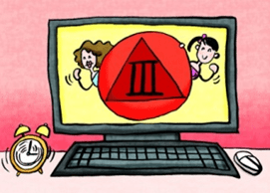 | There are more meaningful and interesting activities in life that can enrich one's life, such as hiking to enjoy the scenery, visiting museums to broaden the horizons, etc.
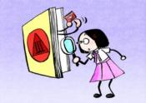  2. We can acquire the right sexual knowledge from pornographic websites. | The contents of pornographic materials are not reliable so they should not be trusted.
3. Exposure to pornographic materials is a desirable way to satisfy sexual curiosity. | It is not worth running the risk of becoming addicted to pornography and acquiring distorted values for satisfying temporary curiosity.
4. If your friends have the habit of using pornographic materials, you will follow naturally. | Entering puberty, teenagers face increasing peer influence. Under the influence of friends and the desire to conform to what their friends are doing, some teenagers encounter pornographic materials. Therefore, it is desirable to make more good friends and stay away from bad friends.

Source of information: Translated from Education Bureau of the HKSAR (2022b), The Intimate Couple (Theme: Public Display of Affection).

8. Compensated dating
- Originally, compensated dating meant girls providing companionship to adult men in exchange for money only, but not based on love, and did not necessarily involve sexual relationships. Nowadays, compensated dating has become a practice which involves adolescents not only providing companionship to adult men or women, but also providing sexual favours in exchange for materials such as money and valuable gifts. Some teenage girls even list charges for different forms of compensated dating on online platforms, including going out, holding hands and having sex.

- Compensated dating will bring crises and negative impacts to society, interpersonal relationships, and the recipients of compensated dating services may need to bear the legal liabilities. Socially, compensated dating rationalizes and beautifies some behaviours on the edge of morality and downplays the crisis of pornography, as well as commodifies romantic and sexual relationships. In terms of interpersonal relationships, the behaviour of compensated dating distorts the concept of gender relations. The dating relationship takes the form of employment which is only based on materials but not on love. This will affect normal social development of adolescents. The recipients of compensated dating services may run the risk of offending the Ordinance of “unlawful sexual activities with underage girls”.

Source: Excerpted, adapted and translated from The Hong Kong Federation of Youth Groups Youth Crime Prevention Centre(2022),Sexual Crisis ; Education Bureau of the HKSAR (2022c), Say no to compensated dating.

Activity 9: What money cannot buy
1. Circle the following objects that cannot be traded by money.
commemorative gift | parental love | friendship | Expensive handbags
professional grade Clarinet | pure body | Healthy and meaningful lifestyle | dignity
the most updated smartphone | trust in a love relationship | love | faithful lover

2. Circle the appropriate words.

The satisfaction brought by objects that can be traded by money is generally more short-lived / eternal; while the satisfaction brought by objects that cannot be traded by money, such as interpersonal relationships and self-worth, is generally more short-lived/ eternal.

9. Naked chat
- Naked chats refer to men and women sending selfied images or videos of their naked bodies to each other on the Internet and text messages about sex (sexting).
There is a chance that naked chats involve scams. Scammers will meet boys or girls through the Internet, show kindness and concern, make people less wary, and then ask for naked chats.
- Naked chatters might be blackmailed by naked chat. Scammers who would use the naked images or videos, sexual text messages (screenshots) as well as stolen mobile phone contact information to blackmail people to use money, sexual intercourse or prostitution in exchange for not publicly displaying the naked images; and threaten to disclose the screenshots to their family, relatives and friends and display them online if they do not comply. Naked chat information would also be used for cyber-bullying. The information would be publicly displayed on social platforms and forums, and it is difficult to delete the information completely. Naked chatters would also be doxed and their personal information would be publicly disclosed. This would affect them and their family life negatively. In terms of interpersonal relationships, when naked chatters have experiencing being blackmailed, they would lose sense of security and trust in interpersonal relationships. This would affect their normal social development. In terms of legal liabilities, sharing naked images would offend the Ordinances of “publicly displaying the child pornography” and “publication or threatened publication of intimate images without consent”.

Source: Excerpted and adapted from The Hong Kong Federation of Youth Groups (2022), Sexual Crisis; Cyberdefender(2022), cyber sex.

Activity 10: Video watching
1. Watch the video clip, answer the following questions.
Values education Sex Education Animation Resources The Temptation of Naked Chat
Theme: Online Naked Chat
Scene 2 (02:38-09:44)
https://www.edb.gov.hk/attachment/en/curriculum-development/4-key-tasks/moral-civic/sea/SEA10_Eng_20160519.mp4
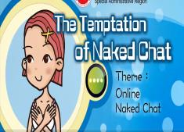

Match the following misconceptions with the suitable clarifications.
Misconception |  | Clarification
- Justin can avoid getting cheated when making friends on the Internet by checking out the contents and photos posted on websites of his Internet friends to learn about their backgrounds. |  | a. Gender and loss are not related. Put aside gender and think thoroughly, would it be fine if your naked photos are forwarded to your classmates, friends and relatives, or even uploaded to your social media groups? Criminals always make use of the mentality that “I’m a guy and I have nothing to lose” to set up online sexual traps in a bid to blackmail the victims. Hence, don’t fall into these traps!
- When an Internet friend invites Justin to have naked chat, Justin thinks that naked chat is an activity by mutual consent. It does not involve money transaction and it will not hurt anyone. Also, he does not have to worry about sexually transmitted infections or unwanted pregnancy. It’s safe and exciting! |  | b. Criminals are not constrained by geographical boundaries. According to the data indicated by the Technology Crime Division of the Commercial Crime Bureau, most of the criminals involved in naked chat were mostly beautiful young women and handsome young men from different parts of the world. They claimed themselves to be South-East Asian, Japanese, South Korean, or even overseas Chinese. Physical distance is less a problem in the Internet world. Anyone, including people residing outside Hong Kong, can easily get your personal information. Do not take it carelessly.
- It’s safer for Justin to have naked chat with overseas Internet friends since they have more open personality and come from a more open culture. What’s more, they know nothing about his background or his friends. It must be safe! |  | c. Criminals will do anything to get what they want. In the Internet world, people can make up a complete personal profile and social circle without much difficulty. To make it more convincing, they would post photos that seem to be taken from their daily lives. Once you’ve added them as friends, they can then collect information about your friends and relatives in your social media groups.
- Boys get nothing to lose even when they are being seen naked. If a boy is invited to naked chat by a girl, it’s like winning a lottery! What dangers can there be! |  | d. Those participating in naked chat may simply want to seek excitement. However, one should never underestimate the danger of naked chat even though it looks safe. People think they have nothing to lose since naked chat seems to bear no cost at all (for example, free of charge, no risk of sexually transmitted infection or unwanted pregnancy), but it is totally wrong! People can hide their identities on the Internet. With the sense of self-protection and safety awareness loosened, people would easily fall into traps when being lured by beautiful young women and handsome young men and when sexually aroused, and even forget the possibility of being photographed or blackmailed. Think twice before you act; the consequence may haunt you for the rest of your life.
Answer:
1 | 2 | 3 | 4
c | d | b | a

Source: Excerpted and adapted from Education Bureau of the HKSAR (2022d), The Temptation of Naked Chat.

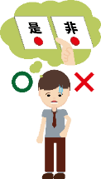
Activity 11: Undesirable behaviours - Right or Wrong?
Read the table below carefully. If you think a statement about undesirable behaviours is correct, please write “Right” in the box; otherwise please write “Wrong” and put down the reasons.

Undesirable behaviours  Right or Wrong | Right or Wrong | Why?
- Some people have addiction problems (such as Internet addiction, addiction to sexual content, gambling, etc.) which lead to negative physical and mental effects, because their will power is not strong enough. I have very good self-control and there will be no problems. | Wrong | - One of the main reasons for addiction is overestimation of one's self-control. One becomes addicted without even knowing it and cannot get out of an addiction.
- As long as I’m a minor, I don’t need to bear any consequences or legal liability for anything done. | Wrong | - Anyone over the age of 14 shall be held legally liable; for serious crimes, even those under the age of 14 may also be held liable.
- Undesirable behaviours are just one way for adolescents to prove that they are adults. It’s not a big deal. | Wrong | - Engaging in undesirable behaviours does not prove that you are an adult. Instead, it may affect your health and ruin your future and happiness.
- My good friends ask me to bully a classmate together. I should join them. | Wrong | - Improper behaviours should be rejected immediately. And as a good friend, you should tell him/her bullying is wrong.
- Sexual harassment? Come on. It’s just a joke. | Wrong | - Sexual harassment offends others. A person who does it may also bear legal liability and consequences. This is definitely not a joke.
- Indulging in the online world, I can escape the distress in reality and effectively relieve pressure. | Wrong | - There are many ways to relieve stress. Addiction to the online world is definitely not a correct and effective way.

Conclusion
There are many kinds of undesirable behaviours among adolescents. The common ones include sexual harassment, bullying, compensated dating, naked chat and various addictive behaviours such as Internet addiction, pornography addiction, gambling, smoking, drug abuse, etc. Although undesirable behaviours do not necessarily constitute crimes, they should not be neglected. Such behaviours not only affect one’s body and mind, but also harm the people around them. When undesirable behaviours get worse, they may eventually lead to tragedies. Therefore, adolescents must always maintain self-discipline and stay vigilant to avoid acquiring undesirable behaviours.

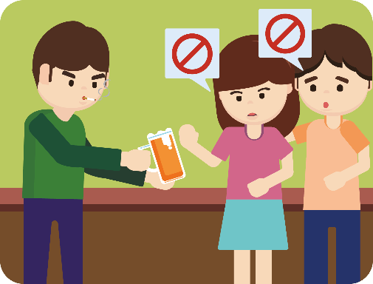


Appendix 3
Know more: Classification of Internet addiction
There are four types of Internet addiction that are more relevant to adolescents, including addiction to online gaming, to online relationships, to online pornography, and to online shopping.
- Addiction to online gaming | The e-sports fever has swept the world in recent years. Mobile and online games have become part of the lives of many adolescents. The World Health Organization listed video game addiction as a new mental disorder in 2018. It refers to one’s continuous inability to control their gaming behaviour and their daily life is affected as a result. According to a survey conducted by the University of Hong Kong in 2017, it was primarily estimated that around 10% of Hong Kong students spent an average of 8 hours daily on playing computer games. They were at risk of online gaming addiction.
- Addiction to online relationships  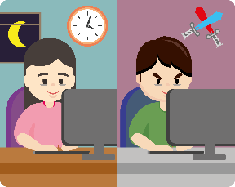 | From ancient times to the present, human beings have made friends and developed friendship through different channels. The increasing popularity of instant messaging tools has indirectly increased our chances of developing online relationships. Besides, the popularity of the Internet allows people to easily talk with strangers through various social media platforms, or even establish virtual relationships. Excessive time spent on online relationship tools such as video calls, dating platforms and social networking sites can make it difficult to separate the virtual world from reality. Obsession with online relationships may reduce one’s interest to meet face to face with their family, partners or friends. One would tend to use the Internet as an escape from reality. It does not help resolve actual problems, which instead would become worse if not timely addressed.
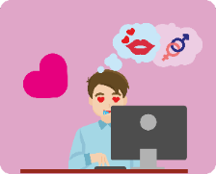  - Addiction to online pornography | The rapid development of the Internet has facilitated the spread of sexual content. On the anonymous Internet, users can hide their identities and browse, obtain, spread and even share sexual content easily without worrying about being discovered. When one is addicted to online pornography, other common sexual addiction behaviours such as excessive masturbation, sexual harassment, online sexual activities, etc. will evolve.
  - Addiction to online shopping | Online shopping has become popular mainly because of its convenience and affordability. Besides, it has gradually changed the conventional consumption pattern. Now many people order goods online instead of visiting stores in person. While there are many benefits to online shopping, a survey released by the Investor Education Centre in 2018 showed that online advertising and promotional offers would tend to trigger spending impulse. Consumers would buy more than needed in the process. They would even regret buying something unnecessary. In the long run, addiction to online shopping will lead to financial burdens. One can easily spend more than they earn and get into debt.

Source: Excerpted and adapted from The University of Hong Kong (2017), Survey on the Gaming Habits among Hong Kong Upper Primary students; Investor Education Centre (2018), Online shopping can be a double-edged sword for consumers Investor Education Centre survey; World Health Organization (2020), Public health implications of excessive use of the Internet and other communication and gaming platforms.
Module 2.1: Overcoming Growth Challenges
The teacher asks students to finish Worksheets 3 and 4 before the class and to discuss and share their work during the class.
(Lesson 3 to Lesson 5)
Learning and Teaching Materials

Worksheet 3: Causes and negative effects of undesirable behaviours among adolescents
Facing different temptations and challenges, not only shall adolescents learn to deal with problems with a positive and active attitude, but they shall also understand the causes and effects of undesirable behaviours, so that they can resist temptations and avoid traps.

In Worksheet 2, we have had preliminary discussion on the reasons why adolescents acquire undesirable behaviours. This Worksheet 3 will discuss three undesirable behaviours, including Internet addiction, bullying and sexual harassment to further explore the causes of undesirable behaviours and their negative effects on adolescents.

Content knowledge 1: Bullying
Generally speaking, bullying includes the three elements below:

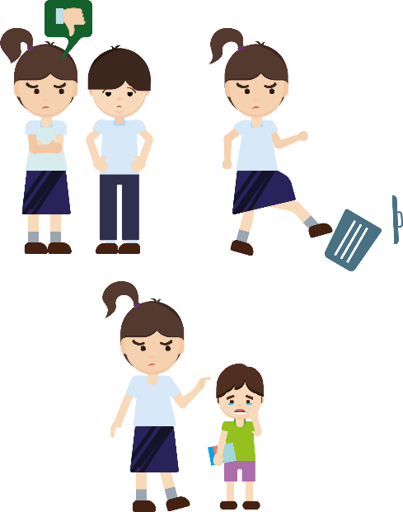
- Repetition: Bullying repeats over time. It is not a single incident.

- Bad intent: Bullies oppress and hurt others intentionally.

- Imbalance of power: Bullies are apparently more powerful and bullying occurs when the victims are unable to defend themselves.

A behaviour is defined as bullying only when it has all these three components.

Overall, bullying is a repeated and intended act of harm or oppression by a person or a group of persons who is/are more powerful or in the majority. Common bullying behaviours include physical violence, verbal attacks, boycotting and cyber-bullying. If bullying causes harm to the victim, it may constitute a crime and the bully shall be held liable.

Source: Education Bureau of the HKSAR (2020a), Understanding Bullying; Emotional Health & Counselling Centre, United Christian Nethersole Community Health Service (undated), A Psychological Perspective on Campus Bullying.
Types and forms of bullying
Bullying can be broadly classified into four categories as follows:
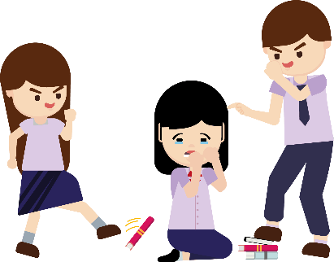
a. Physical bullying with violent behaviour - Punching, kicking, slapping, hitting, shoving, tripping, pulling hair, extorting money or properties, etc.

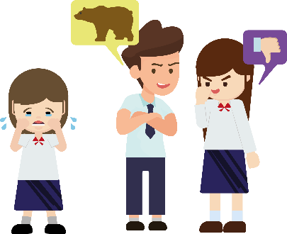
- Verbal bullying - Intimidating, using foul language, cursing, defaming, mockery, name-calling and insulting or making malicious fun of somebody by attacking his/her personal characteristics like appearance, ability, and ethnicity.

- Indirect bullying - Spreading rumours, being hostile, ignoring, isolating, boycotting or rejecting the victim, etc.
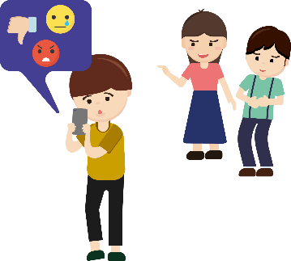
- Cyber-bullying - With the development of information technology, bullies can spread rumours, post insulting remarks or make other personal attacks via electronic means, such as emails, webpages, chat rooms and text messages of mobile phones, to mock and defame the victims. This gives rise to what we call “cyber-bullying”.

People involved in bullying
- Bully - Initiates the bullying behaviour and acts as the leader.
- Follower - Follows the bully and participates directly in bullying, or encourages the bullying behaviour, e.g. by teasing and cheering around.
- Protector - Offers comfort and support to the victim, tries to stop bullying
- Bystander - Observes the bullying but chooses not to speak up or do something about it.

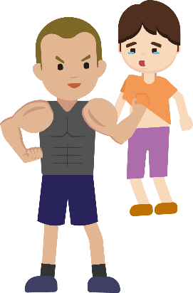
Characteristics of bullies and victims
Characteristics of bullies
- Not good at controlling negative emotions, easily impulsive
- Lack empathy for others
- Compensate for inferiority through power
- May have been victims of violence, and hostile towards others

Characteristics of victims
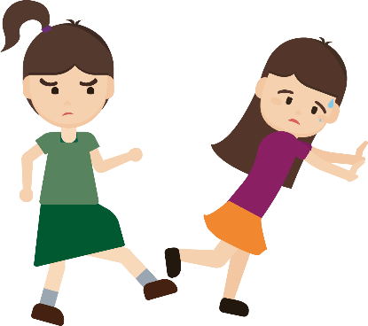
- Tend to be silent, shy and weak
- Have an appearance different from that of classmates of the same age, such as being skinny or fat
- Not sociable, having few friends
- Overprotected or over-controlled by parents

Reasons for bullying
- Personal factors: Bullies are often bad-tempered, impulsive and easy to get angry. Victims, on the other hand, are mostly introverted, lack self-confidence, and have low social skills.
- Family background: There are problems with parenting styles (such as parents who tend to insult and beat their children), or there is a lack of discipline at home.
- Media factors: Some media advocate violent or heroic bullying, making adolescents mistakenly believe that bullying is acceptable. For example, some films or online games advocate the use of violence to solve problems, or spread inappropriate information such as “the law of the jungle”. It would affect adolescents’ values and attitudes towards the relationships with others.
- School factor: If the school does not have an effective policy to prevent and handle bullying, it may be difficult to build a culture of harmony and mutual help in school. Worse still, it may encourage the spread of bullying.

Source: Excerpted and adapted from Emotional Health & Counselling Centre, United Christian Nethersole Community Health Service (undated), A Psychological Perspective on Campus Bullying.

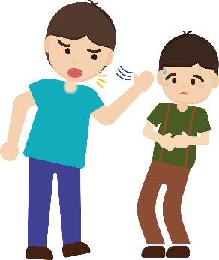
Negative effects of bullying
Bullies and followers
- Psychology: They gradually lose empathy for others. They believe in the law of the jungle and power play. They even have distorted thoughts. Eventually they will form a violent and odd personality.
- Behaviours:
- They tend to express emotions and solve problems through violence. And they can easily have conflict with others.
- After growing up, they may continue to bully and oppress others. Their psychological and mental state will be distorted. And they will be more likely to harm others and commit crimes. It will affect not only their victims, but their own future as well if they are convicted due to bullying.

Victims
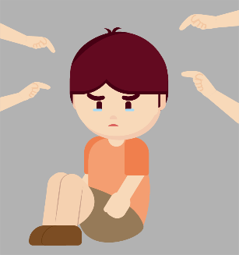
- Psychology: They feel anxious, afraid, and may even develop mood disorders, such as social anxiety disorder, post-traumatic stress disorder (PTSD) and depression.
- Behaviours: They may avoid going to school and refuse to develop relationships with others. The suspicion and distrust of people can seriously affect their social life.

Bystanders
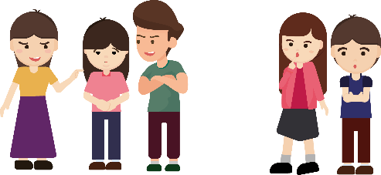
- Psychology: They feel panic because they often hear and see bullying. They are afraid of becoming the next victim, so they may keep silent and support bullying for self-protection. Over time, they may get used to bullying and becomes indifferent when they see someone being bullied. They may even agree with and indirectly encourage bullying.
- Behaviour: If they think that bullying others will not have negative results, then they may even participate in bullying in future.

Source: Excerpted and adapted from Emotional Health & Counselling Centre, United Christian Nethersole Community Health Service (undated), A Psychological Perspective on Campus Bullying.
Activity 1: Case study
Students form groups of four to read the following case and complete the discussion questions.

Case: Who’s bullying
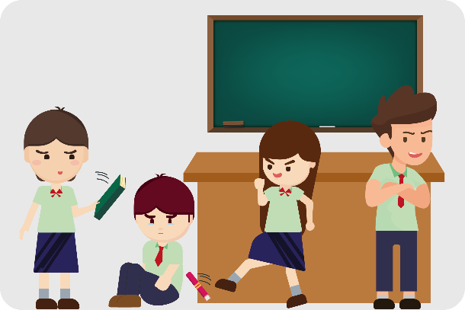
John is a S1 student. He looks stronger than other students, but has a soft voice. A gang headed by Andy nicknamed John “mosquito”. When they walked past him, they often imitated the mosquito noise to laugh at him. Andy also asked other classmates to deliberately isolate John. Whenever Andy was in a bad mood, he would shove and even slap John. One day, Andy and some other students threw John’s schoolbag and belongings into the trash bin. And then they surrounded and scolded John. Fanny even filmed the process with her mobile phone and posted it on social media. Other students just stood and did not lend a helping hand. John was seriously harmed both physically and psychologically.

John had thought about telling his parents what had happened to him in school but he didn’t want his parents to worry about him. He wanted to report the incident to teachers but he feared that if teachers didn’t take it seriously, Andy’s bullying against him would get even worse. Besides, when other classmates didn’t help him, he felt desperate. The bullying lasted for a month. John was afraid of going to school at first. Then he even lost the motivation to go to school and began to skip classes.

Discussion questions:
Undesirable behaviour: | Bullying

Key cause(s): | The bully lacked empathy for the victim and was bad tempered;
 | the followers and bystanders supported by keeping silent and
 | encouraging the behaviour.

- What are the three elements of bullying?
Bullying contains repetition, bad intent and imbalance of power.

- Do you think what Andy and others did to John is bullying? Explain your answer based on the three elements of bullying.
Yes. The reasons are as follows:
- The malicious intent. What Andy and others did to John was
malicious. For example, they shoved and slapped John. They threw
his schoolbag and belongings into the trash bin. And they nicknamed
him and laughed at him. Worse still, they asked other students to
boycott and isolate John. They even filmed the bullying process and
spread it on social media platforms.
- The repetition. Andy and others’ bullying against John was not a single
incident. It had repeated and lasted for a month.
- The imbalance of power. Andy and many other students formed a gang to
bully John. He even asked other students to join the bullying. It is
obviously the stronger oppressing the weaker. There is an imbalance of
power. So what they did is bullying.

- What types of bullying were involved in what Andy and others did to John? Explain with examples.

What they did include the four types of bullying as follows:
- Physical bullying: Andy repeatedly shoved and slapped John. He even
threw John’s schoolbag and belongings into the trash bin.
- Verbal bullying: Andy nicknamed John “mosquito” and imitated the
mosquito noise to laugh at him.
- Indirect bullying: Andy called on other students to boycott and isolate
John.
- Cyber-bullying: Fanny uploaded videos of John being bullied to social
media platforms.

- How does the bullying affect John (the victim), Andy (the bully) and bystanders? Name one of the effects on each of them, both psychologically and behaviourally.
John as the victim
- Psychology: John feels scared and desperate because of the bullying
experience. He has lost the motivation of going to school and confidence
in people. He may even develop more serious psychological problems
Such as depression.
- Behaviour: Due to the bullying, John is reluctant to go to school and his
studies are affected.
Andy as the bully
- Psychology: He will gradually lose empathy for others and believe in the
law of the jungle and power play. And he may even have distorted
thoughts and tell others to “stay loyal or die”. Eventually he will form a
violent and odd personality and develop an unbalanced psychological
state.
- Behaviour: He tends to express emotions and solve problems with
violence. He can easily have conflict with others, harm others and even
commit crimes. This may affect him for life.
Other students as bystanders
- Psychology: They feel panic. They are afraid of becoming the next
victim. So they keep silent and support the bullying for self-protection.
Over time, they may get used to and become indifferent to bullying. They
may even agree with bullying and indirectly encourage bullying.
- Behaviour: If they think that bullying others will not have negative
results, then they may even participate in bullying in future.

- If you were John’s classmate and witnessed the bullying, how would you act as a protector? Propose two actions.

- I would report the incident to teachers so that they would intervene to
stop the bullying. In that way, John would be protected from further
bullying. And Andy and other bullies would be punished.
- Besides, I would encourage other students to form a mutual aid group to
protect John and other students from bullying. And Andy and other
bullies would not think they could outnumber the weaker ones anymore.
- I would also keep an eye on the development of the incident and try my
best to record information to provide evidence to support John’s
complaint.

Content knowledge 2: Sexual harassment
Some adolescents make sexual comments, tell sex jokes and even make inappropriate physical contact when they are around others. These behaviours may constitute sexual harassment or sound threatening and hostile to the other party. They are no fun or jokes but illegal acts.

Sexual harassment mainly refers to making an unwelcome sexual advance or an unwelcome request for sexual favours, or engaging in other unwelcome conduct of a sexual nature, such as making sexual jokes, uploading pornographic images and pictures on social media platforms which offended, humiliated or intimidated the other party.

Causes of sexual harassment
There are many causes of sexual harassment among adolescents. Those causes are interrelated and do not stand alone. The three major causes of sexual harassment are as follows.

a. Adolescents’ characteristics
In their puberty, adolescents are curious and excited about sexual behaviours and the opposite sex. They think it is okay to make jokes about sex. And they even mistakenly believe that the other party likes to be harassed or physically touched. Besides, some adolescents want to build their image in the group and show their maturity, and so they tend to bully and harass the weaker and to express themselves in extreme manners, such as sexual harassment.

- Media influence
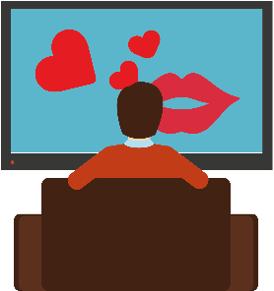
In the mass media, such as social media platforms, TV programmes and publications, it is not difficult to see contents advocating culture of sexual openness, distorted sexual topics and stories, and even pornographic images and scenes. Adolescents facing puberty become curious about sex. Without sufficient knowledge and guidance, they would be easily influenced by the sex culture advocated by the mass media, and may imitate the behaviours and commit sexual harassment.

- Stereotype or prejudice
People of any gender, age and background could face sexual harassment. However, some people’s views on sexual harassment may be biased due to some stereotypes or prejudices. For example, some people believe that women wearing sexy clothing is the main cause of sexual harassment and blame the victims, but this perception is not a fact. Instead, stereotypes and prejudices make the victims ashamed to disclose their experiences. When the victims are asked to testify, they may choose to remain silent because of the social pressure and judgemental remarks. Such stereotype or prejudice not only aggravates the victims’ pain, but it may also give the harassers the illusion of “no complaint, no problem”. Situations may get worse when the harassers are not punished.

Remember that sexual harassment is illegal. The harassers shall be held legally responsible for their actions. Some behaviours, such as indecent assaults, procurement of a sex act by threats, or intercourse by force, are likely to constitute criminal offences. Those who knowingly assist others in sexual harassment shall also be held legally liable.
Here are some common examples of sexual harassment as provided by the Equal Opportunities Commission:

Figure 3 Common types of sexual harassment
Source: Excerpted and adapted from Equal Opportunities Commission (2018, 2020), Understand the Definition of Sexual Harassment and Legal Liabilities.
The teacher can play the sex education animation “Intimacy Boundary” to help students understand the types and examples of sexual harassment.
https://www.edb.gov.hk/tc/curriculum-development/4-key-tasks/moral-civic/sea/sea.html
Activity 2: Quiz about sexual harassment
Which of the following myths about sexual harassment are incorrect? Read the following sentences carefully. Place a “✓” next to the correct ones and “x” to the incorrect ones, based on your opinion.
Myth | Correct | Incorrect | Reasons
- Sexual harassment only happens to young working women. |  | ｘ | - People of any age, gender, and background can encounter sexual harassment.
- If someone is accused of sexual harassment, they can always walk free by using ignorance of the law or honest mistakes as a defence. |  | ｘ | - The Equal Opportunities Commission clearly points out that harassers need to be personally responsible for their illegal acts. And ignorance of the law or honest mistakes cannot be used as a defence.
- I am a male and will not be sexually harassed. |  | ｘ | - Both men and women can become victims.
- Joking on sex-related topics should not be considered sexual harassment! |  | ｘ | - As long as the other party feels offended, humiliated or intimidated, it is an act of sexual harassment.
- It is not sexual harassment if the other person’s body is not touched. |  | ｘ | - Some sexual words, look, tone or exposure can constitute sexual harassment.
- After being sexually harassed, one doesn’t have to blame themselves. Instead, they should tell someone they trust and ask for help. | ✓ |  | - Being sexually harassed is not a personal problem. One doesn't have to blame themselves. Victims should take the initiative to ask for help.
- Sexual harassers are usually strangers. |  | ｘ | - The sexual harasser can be someone you know.
- After being sexually harassed, victims may suppress their feelings. | ✓ |  | - Victims may intentionally suppress their feelings because they are afraid of others' view or feel embarrassed.

Source: Excerpted and adapted from Equal Opportunity Commission（2021），Learn the
law, know your rights; Education Bureau of the HKSAR (2015), Prevention of Sexual Harassment in Schools.

Negative effects of sexual harassment on the victims
Sexual harassment has physical, psychological and social effects on the victims, mainly as follows.

Source: Excerpted, adapted and translated from Education Bureau of the HKSAR (2012), Design of Extension of Learning on Sex Education.
Activity 3: Case study
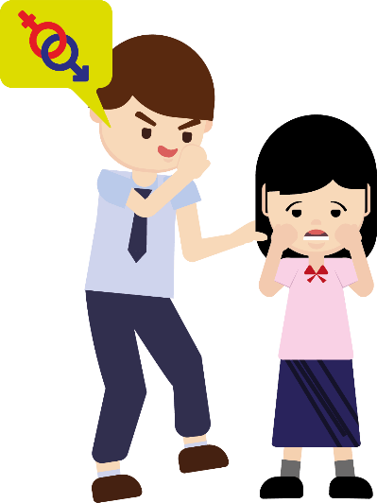
Students form groups of four to read the following case and complete the discussion questions.

Case: Stop sexual harassment
Mike and other boys in the class liked to comment on Venus’ figure. They would look her up and down in a strange way. They would also whistle to her and make sex jokes loudly. Other students would laugh and echo what they say. Venus had expressed that she felt unhappy and offended. She asked them to stop and then left the scene.
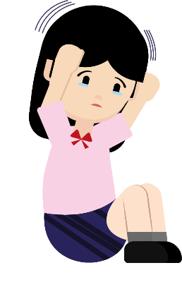
Mike, however, didn’t stop harassing Venus. On a recent occasion, he deliberately caressed her back and hair when walking past her. And then he said it was just joking. Venus was scared. She went to cry bitterly in the toilet. Venus once thought about telling the incident to her parents, but she was worried that if it drew attention, she might be retaliated against by Mike and laughed at by her classmates. She thus chose to keep silent.

Venus felt anxious and scared about the sexual harassment. She was worried that she would be sexually harassed again if she went to school. And she began to blame herself for not being brave enough to face it. She also found that she was gradually afraid of being around the opposite sex. She was afraid that the same unhappy things would happen. She felt sad and had even thought of harming herself in order to forget the scene of being sexually harassed. Venus is living in fear every day, not knowing when she would be sexually harassed again. What should she do?
Discussion questions:
Undesirable behaviour: | Sexual harassment

Key cause(s): | Being curious about sex and exceed the boundary of appropriate
 | relationships with classmates.

- What kind of sexual harassment do you think was involved in what Mike and others did to Venus? Explain with examples.
- What Mike and others did was verbal harassment. They would judge.
Venus’ figure and whistle to her and make sex jokes loudly
- There was also sexual harassment involving physical contact. For
example, Mike once caressed Venus’ back and hair without her consent.
- Looking Venus up and down in a strange way making Venus feel offended
or intimidated was indirect harassment.

- As the victim, how did Venus respond to the sexual harassment? How did it affect her?
- Facing the sexual offences involving words and gazing, Venus expressed
her unhappiness and asked them to stop. She also left the scene
immediately. She cried in the toilet to ease her emotion. She didn’t tell
the incident to her parents because she was worried that if it drew
attention, she may be retaliated against and laughed at. So she chose to
keep silent.
- Feeling anxious and scared about the sexual harassment, Venus avoided
school in case it happened again. The sexual harassment has apparently
cast a shadow on her mind. She also blamed herself for not facing it
bravely and she resisted being around the opposite sex. She lived in fear
every day and had even thought about harming herself. It showed that
she had displayed symptoms of trauma and was on the edge of collapse.

- If you were Venus’ friend, what would you do? Propose two actions.
- I would comfort Venus and tell her that it was not her fault being sexually
harassed. At the same time, I would help Venus bravely and clearly tell
Mike and others at the scene that sexual harassment is wrong, that they
would help Venus report the inciden might have violated the law and that they should stop immediately. I t in detail to the teachers and seek
their support.
- I would also encourage Venus to tell her family, so that they can help and
support Venus through the difficult time.

Content Knowledge 3: Causes and negative effects of drug abuse

Drug abuse generally refers to the consumption of mentally hazardous drugs without a doctor’s prescription or guidance, or for non-therapeutic purposes which causes physical and psychological dependence and harm the body and mind. A person who has ever smoked, inhaled, ingested or injected a dangerous drug will be held criminally liable for an offence under the Dangerous Drugs Ordinance.

Situation of Drug abuse
Drug abuse among adolescents is a very complex social problem. And it has become one of the undesirable behaviours worthy of attention in recent years. Figures from the Central Registry of Drug Abuse of the Action Committee Against Narcotics revealed that the number of reported young drug abusers aged under 21 increased from 394 to 452 when compared with the same period last year. In this group, the most common type of drugs abused was cannabis, followed by cocaine. According to the statistical figures from the law enforcement agencies, the number of young arrestees aged under 21 decreased by 32 per cent. Cannabis and cocaine were the main drugs involved in these arrests. As for young offenders aged under 21 who were sentenced to imprisonment for drug trafficking, more than half of them were sentenced to over five years in prison, and the longest period of imprisonment was nearly 22 years. Drug-taking not only causes serious damage to one’s health, but also destroys one’s future.

Source: The Government of the Hong Kong Special Administrative Region Press Releases, “Drug abuse and drug situation in Hong Kong in first half of 2024”, 20 September2024.

The main reasons for drug abuse among adolescents are as follows:
1. Psychological development during puberty
- In their puberty, adolescents tend to get curious about new things and pursue excitement. At the same time, adolescents pursue a sense of recognition from peers at this development stage. Some may want to get close to their friends and as a result, become easily tempted by peers to take drugs to seek recognition from them.

2. Mental stress

- Undesirable behaviours and mental stress are closely related. Adolescents are facing rapid changes in their growth and pressure from many sources. Some adolescents lack a sense of achievement and satisfaction in reality and feel life is boring. Sometimes they feel depressed so they misunderstand that the drugs can help relieve their pressure. Most adolescents are in a rebellious stage and easily have conflicts with their families. Facing academic pressure and a rapidly changing society, they may also feel confused. Some may wrongly shift to drugs to escape pressure and distress.

Source: Excerpted and adapted from Hong Kong Centre for International Student Assessment of Hong Kong Institute of Educational Research, and Centre for Youth Studies of Hong Kong Institute of Asia-Pacific Studies, CUHK (2019), Health Behaviour in School-aged Children; Read01 (2016), Analysis on the Causes of Adolescents' Internet Addiction.

Negative effects of drug abuse
Drug abuse has serious effects on adolescents’ mind, body and social life. Physiologically, drug abuse can harm their health, which include problems such as hallucination, slow reaction, memory loss and cognitive impairment, decreased muscle energy, bladder damage, increased risk of cancer, etc. Psychologically, after taking drugs, adolescents may have mood swings (anxious, depressed or angry), poor concentration, lack of personal inhibition, etc. Addicted individuals will experience strong cravings for drugs. When they attempt to detox, withdrawal symptoms will appear, such as feeling depressed or grumpy. In terms of interpersonal relationships, drug addiction will adversely affect adolescents’ personal social behaviours. They tend to neglect their families and friends and the relationships with them become worsened.

Figure 4 Effects of drug abuse
Source: Narcotics Division, Security Bureau (2022), Anti-drug information.

Activity 4: Case study
Students form groups of four to read the following case and complete the discussion questions.

Case: Drug abuse due to break up
Lily, a post-00s, was affected by the ending of a love relationship and felt depressed. Tempted by bad friends, she was curious about marijuana. After taking marijuana, she had hallucinations and became emotionally unstable. Sometimes she was excited and laughed, but sometimes she felt depressed and cried. She felt taking drugs could help forget her worries for a short time but when she was not affected by drugs, she felt life was a living hell. After becoming addicted to marijuana, Lily felt there was something wrong with her health. Her weight significantly dropped by 15 kg. She had persistent hair loss and gum recession. She went back to smoking after quitting. Her school life was also adversely affected. She said, “My hands shook when I was doing my homework. In the past, when I revised, I could memorise the contents within an hour. But now, I need two hours to memorise the same contents. My memory got worse even when I talked with my friends, I could not respond to them.” She could not control herself after taking marijuana. She hid in her room all day, taking marijuana there and having her three meals there. Even when she felt sick, she still spent a long time taking marijuana, even though doing so made her feel unhappier. She didn’t go to school and had not gone outside for a few months. She seldom communicated with people in her family, and only talked to them when they delivered meals to her room.

Family members cared about her and persuaded her not to take harmful marijuana again. She felt annoyed and disagreed marijuana was a drug. She scolded them loudly and asked them to leave her alone. Her classmates knew she had drug abuse and cared about her. They persuaded her to stay away from marijuana. She scolded her classmates for interfering with her life. So her classmates stayed away from her, with the result that she became even more isolated. Previously, Lily was well-behaved and diligent. Now, Lily had become a different person. She had become more and more irritable ……

Source: Excerpted, adapted and translated from 香港01新聞（2022）。《毒品案趨年輕化 情傷少女吸大麻解憂：清醒後又跌返 落地獄、好傻》。

Discussion questions:
Undesirable behaviour: | Drug abuse

Key cause(s): | affected by break-up and felt depressed, tempted by bad friends,
 | curiosity

- What are the negative effects of the undesirable behaviour on Lily’s physiological and psychological conditions?
- Physiologically, taking drugs had adversely affected Lily’s health. She
had hallucinations, significant weight loss, hair loss, gum recession,
worsened memory, and poor concentration.
- Psychologically, Lily had mood swings, sometimes she was excited and
laughed but sometimes she was depressed and cried; and taking drugs
made her feel unhappy. She became more irritable.

- What are the negative effects of the undesirable behaviour on Lily’s relationships with others?
- Taking drugs adversely affected her interpersonal relationships. She
didn’t go to school or leave home for a few months. She seldom
communicated with family members. She became angry easily and did
not accept the caring of family members, classmates and friends, making
them stay away from her.

- If a friend of yours has the above-mentioned undesirable behaviour, how would you help him/her get out of the predicament?
- I would tell my friend the negative effects of drug abuse. And I
would encourage and arrange for him/her to participate in different
extra-curricular activities, so that he/she can develop other hobbies.
If necessary, I would also tell teachers, social workers or counsellors
and seek their assistance

Conclusion
With social changes and rapid technological development, adolescents should be vigilant against different kinds of temptations and peer pressure, in order not to develop undesirable behaviours. Overestimating one’s self-control and underestimating the negative effects of undesirable behaviours often lead to undesirable behaviours. Adolescents should keep in mind that they should not act at will. Undesirable behaviours will have long-term negative effects on themselves, others and the community.

For victims of bullying and sexual harassment, their fear and helplessness may last for a lifetime. These emotional traumas often have a profound impact on them. After being offended, the victims lack trust in others and are full of fear of everything. Even if such feelings are not personally experienced, we should understand that the negative effects are particularly far-reaching. Therefore, we should treat others with empathy and put ourselves in their shoes. We should not become harassers or followers. Nor should we be bystanders, pretending to be blind or deaf to the suffering of others. Silence will only encourage unlawful and improper behaviours. To avoid tragedy, we should offer help to the victims and encourage them to seek help from teachers and parents.

For adolescents of drug abuse, they face growth challenges at different aspects in their puberty. They sudden feel lost and abuse drugs. Not only their bodies are hurt, but also their family and friends are mentally hurt as well as legal liability they have to bear. Therefore, we have to be aware of the harm brought by drug abuse, establish the healthy lifestyle to overcome the growth challenges.

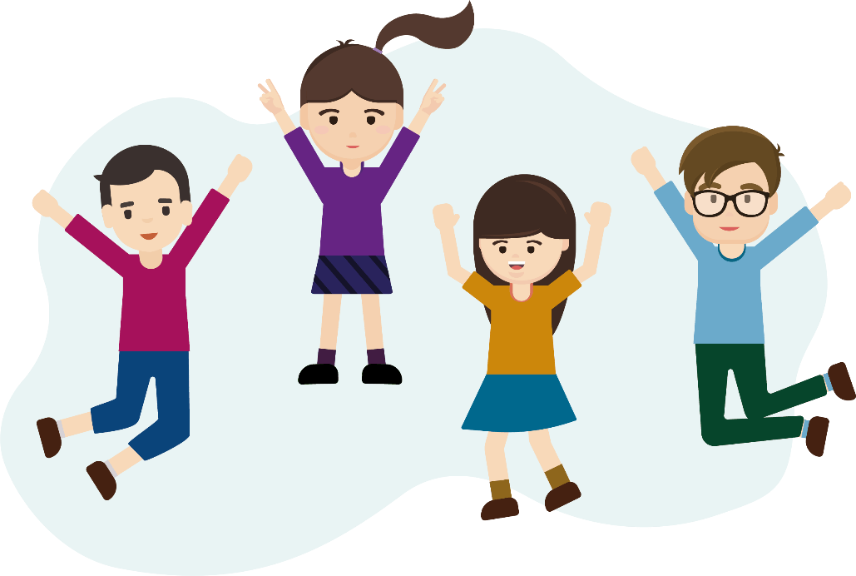
There are many types and causes of undesirable behaviours. We need to learn and think more. To stay away from undesirable behaviours, we should fully understand their causes, find proper solutions and develop correct attitudes in life as early as possible.
Appendix 4
Know more: Consequences and severity of juvenile delinquency

According to Section 2 of the Juvenile Offenders Ordinance (Cap. 226) of the law of Hong Kong, a person under the age of 14 years is regarded as a “child”, and someone being 14 years of age or upwards and under the age of 16 years is a “young person”. If children or young persons commit crimes, juvenile courts will handle such underage offenders by helping them rehabilitate.

The Ordinance also stipulates that no young person shall be sentenced to imprisonment if there are other suitable penalties. Depending on the background of the case and the seriousness of the crime, the court will consider making a probation order, or else sending the offender to a reformatory school, a rehabilitation centre, a detention centre, a training centre or a drug addiction treatment centre. Therefore, we need to understand the possible consequences and severity of undesirable behaviours. We shall refrain from violating the law due to impulse or influence by others. Once convicted in a criminal case, a criminal record will be kept with the court or the police, which will affect future application for certain jobs, qualifications or even be subject to rejection on immigration application.
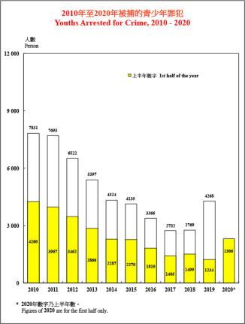

Figure 5 Youths arrested for crime in 2010-2020
Source: Hong Kong Police Force (2020), Overall Crime and Violent Crime Situation.

Appendix 5

Know more: Consequences of and penalties for undesirable behaviours

Examples of penalties related to drugs
Behaviour | Ordinance | Maximum penalty
Selling or supplying dangerous drugs | Section 4 of Dangerous Drugs Ordinance (Cap. 134) | Life imprisonment and a fine of 5 million dollars
Illegal possession or ingestion of dangerous drugs | Section 8 of Dangerous Drugs Ordinance (Cap. 134) | Imprisonment for 7 years and a fine of 1 million dollars
Cultivating any plant of the genus cannabis or the opium poppy | Section 9 of Dangerous Drugs Ordinance (Cap. 134) | Imprisonment for 15 years and a fine of 100,000 dollars
Procuring, supplying or trafficking a dangerous drug for or to a minor | Section 56A of Dangerous Drugs Ordinance (Cap. 134) | A more severe sentence can be passed based on this section
Examples of penalties related to sexual harassment
Behaviour | Ordinance | Maximum penalty
Indecent assault | Section 122 of Crimes Ordinance (Cap. 200) | Imprisonment for 10 years
Indecency with or towards a child under the age of 16 | Section 146 of Crimes Ordinance (Cap. 200) | Imprisonment for 10 years
Examples of penalties related to bullying
Behaviour | Ordinance | Maximum penalty
Criminal intimidation | Section 24 of Crimes Ordinance (Cap. 200) | A fine of 2,000 dollars and imprisoned for two years
Assault and battery | Section 17 of Offences against the Person Ordinance (Cap. 212)  (Shooting or attempting to shoot, or wounding or striking with intent to do grievous bodily harm) | Life imprisonment
 | Section 19 of Offences against the Person Ordinance (Cap. 212)  (Wounding or inflicting grievous bodily harm) | Imprisonment for 3 years
 | Section 39 of Offences against the Person Ordinance (Cap. 212)  (Assault occasioning actual bodily harm) | Imprisonment for 3 years
Fighting in public | Section 25 of Public Order Ordinance (Cap. 245) | A fine at level 2 and imprisonment for 12 months
Source: Excerpted and adapted from Youth CLIC (2020), Common Offences.

Worksheet 4: Strategies to prevent undesirable behaviours in adolescents and help them return to the right path
There are many types of undesirable behaviours. When faced with curiosity, different temptations, conformity and peer pressure, adolescents should get prepared and equip themselves with relevant knowledge. We should understand the negative effects of undesirable behaviours and learn the correct ways to cope with such behaviours with different skills. For example, we may use the strategies to handle conflicts learned in S1 Module 1.2 Interpersonal Relationships and Social Inclusiveness (Part 1) “Enhancing Family Cohesion” to handle conflicts, and the ways to cope with peer pressure learned in Module 1.2 Interpersonal Relationships and Social Inclusiveness (Part 2) “Friendships”. We should analyse the right and the wrong, weigh the pros and cons and also listen to others’ advice, but not follow the trend or the opinions of peers without considering the consequences. Otherwise, we would eventually develop undesirable behaviours which cause negative impacts on ourselves, others and the community.

Mastering the skills to say “no” can prevent adolescents from falling into the trap of undesirable behaviours. Remember that we must learn to bravely say “no” to undesirable behaviours and face challenges and difficulties with a positive attitude.

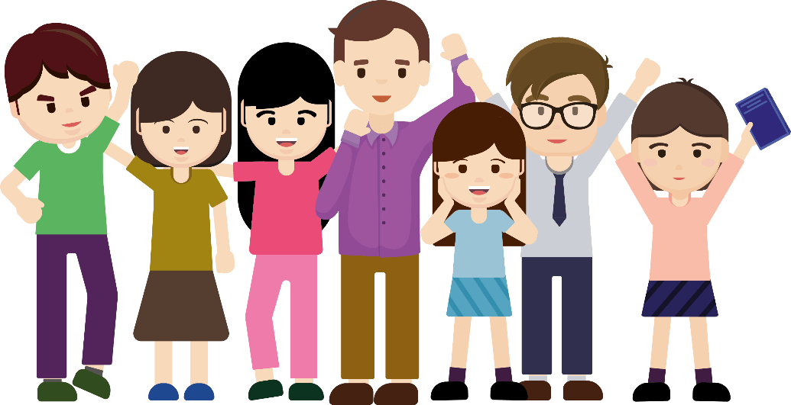

Content knowledge 1: Strategies to prevent undesirable behaviours
Adolescents develop undesirable behaviours mostly because of curiosity and pursuit of excitement, or even impulse. Therefore, when we feel hesitant, we should first calmly and objectively analyse the right and the wrong, evaluate the pros and cons and the consequences, or ask others for advice. Remember that self-discipline, self-control and self-reflection are very important. We should dare to say “no” to any undesirable behaviours. If friends make unreasonable requests, in particular those related to illegal acts, we should not be subject to peer pressure or influence by media without considering the consequences. We should adhere to our principles and bravely say “no”; otherwise we would harm ourselves and others.

To prevent undesirable behaviours, adolescents may start from learning the “NOT” skills, that is, No, Off and Tell.

Figure 6 Three steps to prevent undesirable behaviours - NOT

a. NO
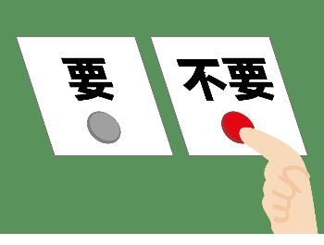
- When our peers induce us to engage in undesirable behaviours which may even violate the conscience and the law, we must bravely express our position. Say “NO” to undesirable behaviours. Peers may use pressure or false information to influence our judgement. A moment of weakness or trust in bad friends may bring serious consequences. Therefore, we must reject undesirable behaviours with a determined tone and clear words.
- For example, when some friends ask us to join them to bully another student to exchange for their acceptance to be part of their gang, we should firmly say “no”.

- OFF
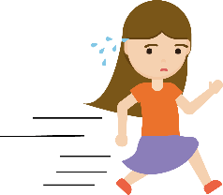
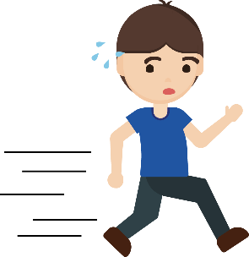
- Faced with different temptations and a wide range of undesirable behaviours, adolescents should not overestimate their self-control and resistance to temptations. On the contrary, withdrawal at the right time is the wise choice. In the face of undesirable behaviours, we should leave the high-risk scene, such as avoiding too much time on social media and contact with bad peers. Instead, we should meet good friends who offer mutual support and have positive peer influence on us. We should face challenges of growth with a positive and healthy attitude.

- TELL
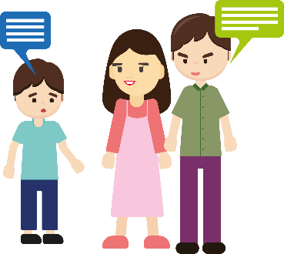
- When faced with challenges and pressure during our growth, we may be susceptible to misleading information from peers and the media and fall into the crisis of engaging in undesirable behaviours. Remember, we do not have to face challenges alone. Instead, we can ask the right people around us, such as parents, teachers, social workers and counsellors, for help and advice. There are always more solutions than difficulties. We can discuss our concerns and problems with someone we can trust to get help and counselling.

Source: Education Bureau of the HKSAR (2020d), Co-creating a Harmonious School – “Stop Bullying" Resource Package.

Content knowledge 2: Strategies to return to the right path
              - Differentiating between true and false information

- We can easily encounter a lot of fake information and wrong concepts, whether on the Internet, on social media, or when we share information with friends. Some adolescents lack sufficient ability to judge and identify false information. For example, some may mistakenly believe that Internet addiction is a trend for adolescents, bullying is one way of dealing with interpersonal relationships, and sex topics are a way to show their humour. Adolescents should develop critical thinking, and to identify true or fake information, so as to minimise the chance of acquiring undesirable behaviours.

              - Building law-abiding awareness
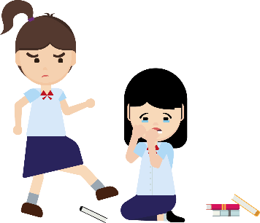
- Undesirable behaviours do not only affect the victims’ body and mind, but also put the perpetrators at risk of breaking the law. Some serious acts such as indecent assault and wounding are criminal offences. Once convicted, the offenders may have criminal records and be sentenced to imprisonment, losing their freedom and future. Adolescents should build law-abiding awareness and strengthen the understanding of the rule of law. It helps us maintain awareness of preventing ourselves from engaging in undesirable behaviours and understand the importance of respecting and safeguarding the rule of law, even when faced with ever-changing social environment and various temptations.

              - Developing positive values and attitudes
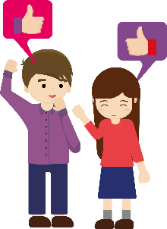
- Developing positive values and attitudes helps us reject undesirable behaviours in a world of fierce competition and various temptations. Positive values and attitudes can be used as standards for our actions and judgements, helping us face pressure and difficulties with determination and build relationships with friendliness and mutual respect. If we make mistakes, we should take responsibilities and bravely admit and correct them. We should treat others with empathy and care, learn how to put ourselves in others’ shoes, and reflect the possible influence of our behaviours on others. Doing so helps us adhere to our principles and firmly say “no” to undesirable behaviours.

Source: Excerpted and adapted from Education Bureau of the HKSAR (2017; 2020e), Booklet 6A: Moral and Civic Education: Towards Values Education; Caring for Students and Helping them Get Back on the Right Track.
Activity 1: Approaches to prevent undesirable behaviours and strategies to return to the right path
Read the following cases carefully. Based on the information above and your personal experience, write down details of the ways to prevent undesirable behaviours (i.e., NO, OFF and TELL) and the strategies to return to the right path. And tick “” the relevant values/attitudes in the cells on the right, or else provide your personal opinions in “Others”.
 | Case | Ways to prevent undesirable behaviours and strategies to return to the right path | Desired values/attitudes
 | Leo was introverted and was often bullied and teased by his classmates. For example, other students would throw his schoolbag in the trash bin, or wet his clothes. Students witnessing these incidents would just keep laughing, film the process and shout with excitement. Leo was even asked to hand over his pocket money in exchange for everyone’s friendship.  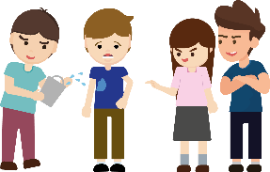 | - Leo should immediately reject (NO) the physical bullying and ask them to stop.  - For the demand for money, he should flee the scene right away (OFF) and avoid direct confrontation.  - Finally, Leo should tell someone he trusts such as teachers (TELL) and ask for help. | Courage  Determination  Autonomy  Rationality  Self-reflection  Self-discipline  Principled morality  Compliance with the law  Courage to seek help  Others:_____________
 | Fanny was studying in the library. when she noticed that her classmate, Kenny, often found excuses to touch her on the shoulder or waist. Fanny felt uncomfortable and uneasy about the touching. | - Fanny should express her feelings to Kenny and firmly reject his improper behaviour (NO).  - She may stop going to the library and instead stay at home to study homework. (OFF).  - Fanny should bravely reject Kenny’s offensive behaviour and tell the matter to someone she trusts (TELL).  - Kenny should enhance his understanding of boundaries when getting along with the opposite sex, to avoid inappropriate behaviours. | Courage  Determination  Autonomy  Rationality  Self-reflection  Self-discipline  Principled morality  Compliance with the law  Courage to seek help  Others:_____________
 | Shad likes making friends and enjoys being with friends. On one occasion, he attended a friend’s birthday party. His new friend Shawn took out a packet of powder and tried to induce Shad to take drugs. He even said it would not be addictive. He kept asking Shad to try it.  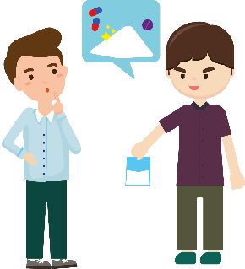 | - Shad should immediately reject Shawn (NO) and point out that possessing or taking drugs is illegal. As a friend, Shawn should not ask him to break the law.  - Shad should leave the party as soon as possible and avoid contact with Shawn again (OFF).  - Shad should tell the incident to someone he trusts (TELL) and ask for advice.  - Shad should get a better understanding of drug-related crimes (such as possession or ingestion of dangerous drugs; procuring or supplying a dangerous drug for or to a minor). He may also share the information about the penalties and crimes with his friends to build law-biding awareness together. | Courage  Determination  Autonomy  Rationality  Self-reflection  Self-discipline  Principled morality  Compliance with the law  Courage to seek help  Others:_____________
 | Ted often played video games with his classmates during the summer holidays. On one occasion, some online friends mentioned that outstanding gamers could become e-sport players with generous prizes and a bright future. So Ted played video games for twenty hours a day to improve his skills. Even if he started to get exhausted and his hands began to shake uncontrollably, he still continued playing games day and night. His parents once persuaded Ted to study hard and get rid of the obsession. Instead of taking his parents’ advice, Ted lost his temper and scolded his parents. Eventually, Ted left home and continued indulging in online games at an Internet cafe.   | - Ted should develop self-discipline. He should make and adhere to a reasonable schedule, instead of playing video games day and night (OFF).  - Ted should stay away from bad friends who are also addicted to online games. He should avoid peer temptations and addiction to online games (NO).  - Ted should differentiate between true and fake information. He should have a better understanding of the e-sport industry, which requires a lot of considerations and efforts. As he is still a student, he should choose very carefully.  - Ted should develop positive values and attitudes. He should reflect on the mistake of harming the relationship with his family because of his indulgence in video games. He should understand the physiological and psychological effects of video game addiction. | Courage  Determination  Autonomy  Rationality  Self-reflection  Self-discipline  Principled morality  Compliance with the law  Courage to seek help  Others:_____________

Module 2.1: Overcoming Growth Challenges
(Lessons 6 and Lesson 7)
Learning and teaching materials for an enquiry learning activity
Cater for learner diversity: The teachers can moderate the task demands according to students’ abilities. For the less abled students, teacher can provide students with choices (e.g. keywords bolded) to complete the fill-in-the-blank questions. For the part of the worksheet on the methods to reject the addictive behaviours and strategies to return to the right path, for more abled students, they can directly extract the strategies from the reading source and make suggestions on solutions based on materials collected from online sources.

• Students work in groups of four to study Category A addictive behaviours (including drug abuse, smoking, gambling, Internet addiction, pornography addiction) and Category B undesirable behaviours (including bullying, sexual harassment, compensated dating, naked chat). Each group will be assigned with two cases of addictive behaviours or two cases of undesirable behaviours.
• Groups to study Category A addictive behaviours: Students read the assigned cases first, then discuss and fill in the worksheets on the background features of the addictive behaviours, behavioural features, consequences, and methods of rejecting the addictive behaviours and strategies to return to the right path. Then they identify the common and different background features, behavioural features, etc. of the two addictive behaviours. After the group work, they report the discussion results to the class.
• Groups to study Category B undesirable behaviours: Students read the assigned cases first, then discuss and fill in the worksheets on the causes for the undesirable behaviour, the negative effects on self and others, the right way to get a sense of satisfaction, methods of rejecting the undesirable behaviours and the strategies to return to the right path. Then they identify the common and different causes of the two undesirable behaviours, etc. After the group work, they report the discussion results to the class.

Case study activity worksheet (1): Addictive behaviour- Drug abuse case
Chu Fai had drug abuse for years and he was not interested in his study and always fell behind in schoolwork. He didn’t have any sense of achievement in life and had to face the pressure of being a repeater in school. He was impulsive and became interested in drugs. He was greatly saddened by the death of his mother due to sickness. At that time, he was tempted to take ketamine by his drug-addicted girlfriend. After taking the drug, he felt pleasure and had hallucinations. He always had a runny nose when he had a drug craving. After drug abuse for a year, he acted mysteriously and slept for 13 hours per day, and got drug powder on his nose. When his family discovered that he took drugs, they felt shocked. They could not accept his addictive behaviours and asked him to leave home. He borrowed money from his friends for buying drugs but did not pay it back so his friends stayed away from him. Drug abuse also made him suffer from pain during urination, frequent urination and even incontinence. When he was 24 years old, he offended against the ordinance of “possession of dangerous drugs”, and he was remanded at the Lai Chi Kok Reception centre due to possession of dangerous drugs. There, he met a 60-year-old man who did not have any family members or friends visit him. Chu didn’t want to disappoint his family and be abandoned by them. He was determined to quit drugs and changed his bad habits. He was also determined to be a video production instructor and use the camera to share his experiences.

He reminds the teenagers to reject the invitation to drug abuse from bad friends and stay far away from bad friends to resist temptations, and advised teenagers to seek prompt help from teachers, social workers, professionals and police so that there will be early intervention to prevent the problem from further worsening. After release from prison, he reflected on the scourge of drug abuse which had brought emotional disturbance to his family so he was determined to ensure he would not make the same mistake again. He changed his mobile phone number immediately and cut all contacts with his bad friends. He knew if he meets the temptation of drugs again, he would be able to distinguish right from wrong and clear about the serious damage of drugs, so that he would not touch drugs again to prevent the loss of a fulfilling life. When he faces life challenges, he would talk to social workers and his family.

Source: Excerpted, adapted and translated 香港01新聞（2020）。《吸毒青年受師父啟發 立志成影音導師 用鏡頭分享經歷》; Hong Kong Police Force (2022), A chronicle of juvenile crimes – Strategies for teachers and parents.
1. Features of background | - Personal factor:  - Lacking a sense of achievement in life  - Facing pressure of having to repeat a grade in school  - Being impulsive  - Being curious about drugs  - Family factor: Death of mother was a shattering blow to him  - Social factor: Peer influence, tempted by his drug-addicted girlfriend
2. Features of addictive behaviours | - Physiological: Felt pleasure, had hallucinations, runny nose when having a drug craving, needed to sleep for over 10 hours per day, and got drug powder on his nose  - Social: Acted mysteriously
3. Consequences of drug abuse | - Physiological: Suffered from pain during urination, frequent urination, incontinence  - Interpersonal relationship:  - Family could not accept his addictive behaviours and asked him to leave home  - Friends stayed away from him  - Legal liabilities: Offended against the ordinance of “possession of dangerous drugs” and was remanded at a reception centre
4. Reject addictive behaviours and strategies of getting back on track | - Cut all contacts with bad friends (e.g. changing mobile number immediately)  - Seek prompt help from teachers, social workers, professionals and police to prevent further worsening of problems  - Uphold empathy and reflect on the scourge of drug abuse on self and family  - Be determined not to make the same mistake again to overcome recurrence  - Remember the strategies learnt and put them into practice
Case study activity worksheet (2): Addictive behaviour- Smoking case
Siu Lai faced academic pressure at secondary school. Driven by curiosity, she started smoking. When she was young, she saw family members smoke at home, and her friends also smoked when they hung out, so she was not aware that cigarettes were harmful. She could not control herself and smoked more than ten cigarettes every day. Finally, she felt tired, sleepy and lost appetite. When she smoked, second-hand cigarette smoke coming out from windows of her home. Her non-smoking neighbours were forced to breathe in second-hand cigarette smoke and they were so angry that they scolded her. One day, she smoked in a non-smoking area and offended against the “Fixed Penalty (Smoking Offences) Ordinance” with a $1500 fixed penalty. Later, she suffered from a sore throat for a long time and sought medical help. Finally, she was confirmed to suffer from Nasopharyngeal carcinoma phase 3 and the doctor pointed out that her illness was related to her smoking habit. After this, she quitted smoking.

Siu Lai mentioned that when she received medical treatment and there was the recurrence of her smoking addiction, she felt dizzy and tired, her mouth was sore, her taste buds were destroyed, she could not eat for 3 months during the medical treatment, and her weight dropped to around 80 pounds. Her beautiful face was also affected and this upset her a lot. Luckily, she met a group of volunteers who were rehabilitation clients with Nasopharyngeal carcinoma. Their encouragement and experience made her feel hopeful and confident. After her recovery, she had to look around when she was on the street. She had to be careful if any people smoked around her as the sequelae of medical treatment was when she smelled the smoke, she would cough, her nose would bleed and she would vomit. She encouraged teenagers to reject the invitation of smoking from bad friends and stay away from friend circles that tempt them to smoke. When facing pressure, we can exercise, listen to music for relieving the pressure as well as seek suitable people such as counselors to talk to. When quitting smoking, we have to be determined, join quit-smoking counseling services, and stay away from the place where people smoke. She reflected that smoking would harm others’ health, making other people breathe in second-hand or even third-hand cigarette smoke. She is determined to quit smoking for her own and others’ common good.

Source: Excerpted and adapted from COSH (2022), Being young is not an excuse for not quitting smoking, Montagut Chuen was diagnosed with nasopharyngeal cancer at 22.
1. Features of background | - Personal factor:  - Facing academic pressure  - Family factor: Family members had the habit of smoking  - Social factor: Peer influence, her friends were cigarette smokers
2. Features of addictive behaviours | - Physiological: Addicted to cigarettes, felt tired and sleepy, and lost appetite  - Psychological: Could not control herself and had to smoke regularly
3. Consequences of smoking | - Physiological:  - Suffered from Nasopharyngeal carcinoma phase 3  - Her mouth was sore, her taste buds were destroyed and her weight dropped  - The sequelae of medical treatment was when she smelled the smoke, she would cough, bleed in the nose and vomit  - Psychological: Smoking damaged appearance of her face  - Interpersonal relationship: Second-hand cigarette smoke annoyed her neighbours  - Legal liabilities: Offended against the “Fixed Penalty (Smoking Offences) Ordinance” with a $1500 fixed penalty
4. Reject addictive behaviours and strategies of getting back on track | - Stay away from bad friends  - Do exercise, listen to music to release pressure  - Talk to suitable people such as counselors  - Be determined to quit smoking to overcome recurrence  - Uphold empathy and reflect on harm of smoking on own and others’ health  - Remember the strategies learnt and put them into practice

Case study activity worksheet (3) : Addictive behaviour- Gambling addiction case
19-year-old Ah Yan was addicted to online games when he was young. He did not want to go to school. He was impulsive and always argued with his family. He had quitted school since 16 years old and joined the labour market. He faced great pressure from work. He did not feel any sense of satisfaction in life. He said when surfing the Internet, pop-up advertisements of online gambling aroused his curiosity. He said he was introduced by colleagues to do illegal gambling of online “baccarat” and football betting which made him addicted to gambling. “The process of winning money is very exciting. But when I bet more, I lose more. I receive calls which offer loans every day. Since then I always borrow money, gamble and lose money. My bets are out of the amount I could withstand.” He said that he had owed debts of more than $1,000,000 which were finally paid by his family who felt very disappointed in him.

After learning a lesson, Ah Yan had tried to quit gambling many times but failed. He lost self-control and started to bet without resting and eating. Recently, he owed $200,000 due to gambling. To avoid disappointing his family again, he filed for bankruptcy. Besides, he offended against the ordinance of “illegal gambling” and was liable to a fine of $10,000 and imprisonment for 6 months. He recalled his memory and pointed out that if there was the opportunity to choose again, he would have assertively rejected gambling, and stayed far away from colleagues who introduced him to gambling and sought help from reliable people such as family members and social workers to deal with the growth challenges. After released from the prison, he was a volunteer for animal services. He hoped that he had no free time to play online games and gamble. He reflected, “Exchange the excitement of gambling for money made me happy for a short while; but when back to reality, I discovered I owned nothing and felt empty! Having a healthy and meaningful life can fill the mental emptiness and make life fulfilling. From working for animal services, I have discovered my strength of being a careful person and I love animals so I would like to be an animal care worker.” He regrets being addicted to gambling in the past and that his heavy debts has disappointed his family. So he will spend time with his family talking to them so as to enhance the cohesion of the family. He urges people to be aware that illegal gambling has the risks of offending against the law and losing one’s freedom and personal prospects.

Source: Excerpted, adapted and translated from 路德會青亮中心（賭博失調者輔導及治療中心）（2021）。《小機迷課金成癮 淪賭徒欠債百萬》。
1. Features of background | - Personal factor:  - Lacking a sense of satisfaction in life  - Facing pressure from work  - Being curious about pop-up advertisements of online gambling  - Being impulsive  - Family factor: Alienated family relationships, frequently argued with members of family  - Social factor: Peer influence, colleagues are illegal online gamblers  - Social factor: Received calls offering easy loans frequently, with the result he borrowed a lot of money
2. Features of addictive behaviours | - Placed bets which exceeded the amount he could withstand  - Had tried to quit gambling many times but failed  - Lost self-control and borrowed money to gamble  - Did not care about proper rest and meals
3. Consequences of gambling addiction | - Personal: Owed debts of more than $1,000,000  - Interpersonal relationship: Disappointed family  - Legal liabilities:  - Needed to file for bankruptcy when unable to pay back borrowed money  - Offended against the ordinance of “illegal gambling” and was liable to a fine of $10000 and imprisonment for 6 months
4. Reject addictive behaviours and strategies of getting back on track | - Stay away from bad friends  - Talk with reliable people such as family members and social workers  - Join volunteer services  - Uphold empathy, and reflect on adverse effects of gambling addiction on oneself and family  - Be aware of illegal gambling that would make people fall at the risks of offending against the law and losing freedom and personal prospects

Case study activity worksheet (4) : Addictive behaviour- Internet addiction case
Recently Siu Keung’s parents discovered that Siu Keung spent more time playing online games. His academic performance fell behind and he lacked a sense of achievement in life, making him feel enormous pressure in study. He felt frustrated. He was interested in innovative online gaming rules. He acted impulsively and bought newly released gaming credits. His friends liked playing online games very much and Siu Keung started to play online games with them. His parents’ work hours were long and as a result, they did not care for him very much. As he received a lot of appreciation and recognition from other online game players, he spent more time playing online games. Siu Keung was addicted to online games and he lost self-control. Recently he hid himself in his room to play online games for a whole day. Three meals were delivered to his room by his parents. Though feeling tired, he still spent a long time playing online games even though he had sore hands tired and blurred vision. He did not go to school or left home for a few months. His parents and friends tried different means to urge him to stop playing online games but he found their concern irritable, scolded them loudly and asked them to leave him alone. All these worsened his interpersonal relationships. He quitted school and he became very bad-tempered. Now, Siu Keung urges teenagers that when classmates invite them to play online games for a long time, they should reject them assertively, stay away from them, and seek help from parents, teachers and social workers. He also advices teenagers that as students, they should put priority on their studies, should be self-disciplined, manage the time for studying, leisure and resting, and avoid spending a long time playing online games. We should join more extra-curricular activities or community activities, discover our talents, and grasp the individual and social development opportunities. Siu Keung reflected that it is not worthwhile to destroy the relationships with family due to online games. When we face challenges and setbacks, we could talk to social workers and discuss with them strategies to tackle them. We have to improve our current addicted behaviours addiction and restrict the amount of time spent on computers and slow down the Internet speed. The above can help us tackle Internet addiction.

1. Features of background | - Personal factor:  - Lacking a sense of achievement  - Facing study pressure  - Being curious about innovative online gaming rules  - Receiving appreciation and recognition from other online game players  - Being impulsive  - Family factor: Lacking parental care, parents were busy working and they did not care for him very much  - Social factor: Peer influence, friends liked playing online games
2. Features of addictive behaviours | - Lost self-control, three meals were delivered to his room by his parents  - Though feeling tired, still spent a long time playing online games  - Quitted school  - Did not leave home a few months
3. Consequences of internet addiction | - Physiological: Suffered from sore hands and blurred vision  - Psychological: irritable  - Interpersonal relationships: Worsened the relationships with family and friends, found their concern irritable and scolded them loudly, and asked his family to leave him alone  - Study: Quitted schooling
4. Reject addictive behaviours and strategies of getting back on track | - Stay away from bad friends  - Seek help from parents, teachers and social workers  - Manage and utilise time effectively  - Uphold empathy and reflect that it is not worthwhile to destroy the relationships with family members due to online games  - Talk to social workers and discuss with them the strategies to tackle the problem  - Remember the strategies learnt and put them into practice
Case study activity worksheet (5) : Addictive behaviour- Pornography addiction case
Jay has repeated a grade in school twice and he lacked a sense of achievement in life. He worried that he would still fall behind in schoolwork and need to repeat a grade again. He was impulsive and fought with his classmates. His parents were busy working and his family relationships were not close, making him desire close relationships with others. Online pop-up pornographic advertisements arouse his interest in pornography. When he was young, he always stayed on the street to meet different friends, and sharing pornographic information was common in his circle of friends. He sought comfort from sexual satisfaction and was addicted to pornography and masturbation. Jay could not control himself. He had the habit of watching sex videos and masturbated once to twice every day. He even fantasised about indecently assaulting another person. He was worried about offending against the law so he did not dare to try. As he spent a long time surfing the Internet on his mobile phone, his eyes always focused on the small screen and his vision became blurred. When he was in Secondary 3, his head was filled with pornographic images and he could not stop making sexual remarks in front of female classmates. Classmates were offended and complained that his behaviour was verbal sexual harassment, which worsened his interpersonal relationships in school. He watched sexual videos on MTR and offended against the ordinance of “misconduct in public places” and sentenced to imprisonment for 12 months.

The social worker suggested to him that when his friends shared pornographic information, he could change topic to avoid further discussion. When seeing pornographic information, we have to stay away from it promptly. When feeling lonely, you can talk to friends or social workers. He received sexuality counseling service for adolescents. The social worker taught him the limits of sex and the definition of sexual harassment, ways to distinguish between the right and wrong of pornography, and ways to reduce his dependence on pornography and need for masturbation. He learned the strategies of self-control and transfer, and the right way of social life participation. For example, through serving as volunteer for the aged, he could feel the happiness of helping people and meeting friends who support each other.

Source: Excerpted, adapted and translated from Hong Kong Caritas Youth and Community Service (2020), Sexual fantasies.

1. Features of background | - Personal factor:  - Lacking a sense of achievement in life  - Facing pressure in study  - Being impulsive  - Being curious about online pop-up pornographic advertisements  - Seeking comfort from sexual satisfaction  - Family factor: Alienated family relationships, parents were busy working  - Social factor: Peer influence, friends liked sharing pornographic information among themselves
2. Features of addictive behaviours | - Psychological:  - Lost self-control, watched sex videos and masturbated frequently  - Had sexual fantasies
3. Consequences of pornography addiction | - Physical: Suffered from blurred vision  - Psychological: Fantasised about indecently assaulting another person  - Interpersonal relationships: Worsened interpersonal relationships, made sexual remarks in front of female classmates and offended them  - Legal liabilities: Offended against the ordinance of “misconduct in public places” and sentenced to imprisonment for 12 months
4. Reject addictive behaviours and the strategies of getting back on track | - Stay away from bad friends  - Talk to friends or social workers when feeling lonely  - Join healthy social activities, for example, serving as volunteer for the aged  - Remember the strategies learnt and put them into practice

Case study activity worksheet (6) : Undesirable behaviour- Bullying case
An incident of school bullying occurred in a primary school. During the suspension of school under the COVID-19 pandemic, primary school student Siu Fu started a fight with Siu Ming, a classmate who was not good at interacting with people, due to Siu Ming’s poor attitude. Siu Fu always idled around doing nothing. He was impulsive and he always played online games to relieve the pressure. His dad always hit and scolded him at home, and he did not have any sense of satisfaction in life. Therefore, he always imagined himself as a powerful warrior in online games who solved problems by bullying. Siu Fu always verbally attacked Siu Ming in the class Whatsapp group and he changed Siu Ming’s photo to an emoji. When resuming school, Siu Fu took revenge on Siu Ming. He and other three classmates took Siu Ming to the park. Siu Fu pushed Siu Ming’s head to the ground strongly to make him apologise. Siu Ming did not dare to tell his family and he felt worried and anxious. The whole process videotaped by one of the classmates. A parent shared the video in the parents’ group. Siu Ming’s parents discovered it and called police to handle it. Police reported that Siu Fu and his classmates had offended against the “Criminal Intimidation Ordinance” and were liable to a fine of $2000 and imprisonment for 2 years. Since then, Siu Ming lost the motivation of going to school, he did not trust people and had to receive psychological counseling.

The teacher suggested to Siu Ming that when facing bullying, he can be courageous to seek help from teachers, family members or reliable people to stop the recurrence and spread of bullying incidents. The teachers also suggested to Siu Fu that he could gain a sense of satisfaction and enhance his self-esteem by helping others. He could also make good use of IT skills to design positive and encouraging emojis to share positive energy with classmates. When bullying occurs in his family, he should seek help from social workers and relieve negative emotions properly such as doing exercise, writing about feelings and meditation. The teacher also reminded other students that they should uphold positive values, and that when friends asked them to bully others, they should assertively refuse to accept their request to be followers of the bully; promptly leave the site; remind others that bullying behaviours would offend against the law and once convicted, they would have criminal records and be sentenced to imprisonment; and seek help from parents and teachers. This can help the victim to escape from the predicament and to prevent the bully from hurting others. When the bully has negative emotions, he/she should control his/her behaviour, and think about whether the bullying behaviour would have long-lasting harm on others. Facing disputes in interpersonal relationships, we must know how to deal with them, use appropriate ways to solve them, or seek the help of a third party to intervene in solving them. The followers and the bully should be courageous to admit and correct their mistakes and apologise to the victim.

Source: Excerpted and adapted from 香港01新聞（2022）。《復課即爆欺凌事件 小五生疑被迫「三跪九叩」道歉 警拘兩同學》。

1. Causes of undesirable behaviour | From the view of the bully (Siu Fu):  - Personal factor:  - Lacking a sense of satisfaction in life  - Being impulsive  - Fantasising himself as a powerful warrior  - Believing that problems could be solved by bullying  Family factor: Lacking parental care, his dad was a negative role model who always hit and scolded him
2. Types and means of undesirable behaviour | - Cyberbullying: Siu Fu always verbally attacked and teased Siu Ming in the class Whatsapp group  - Physical bullying: Siu Fu pushed Siu Ming’s head on the ground strongly to make him apologise
3a. Why does undesirable behaviour cause the character a loss? | - Legal liabilities: Siu Fu and his followers offended against the “Criminal Intimidation Ordinance”, liable to a fine and imprisonment for 2 years
3b. Negative impacts on others | - Psychological: Siu Ming suffered from anxiety  - Social: lost the motivation of going to school  - Interpersonal relationships: did not trust people
4. If the character wants a sense of satisfaction, what is the proper mean? | - Helping people can help him gain a sense of satisfaction and enhance his self-esteem  - When bullying occurs in the family, he should seek help from social workers and relieve negative emotions properly
5. Reject undesirable behaviour and strategies of getting back on track | - The followers:  - Stay away from bad friends  - Remind others that engaging in bullying behaviours has the risk of the offending against the law  - Talk to parents and teachers about the bullying incident  - The bully:  - He/she should control his/her behaviour and think about whether the bullying behaviour would hurt others  - Uphold empathy when dealing with disputes with others and use appropriate ways to solve them  - Remember the strategies learnt and put them into practice

Case study activity worksheet (7) : Undesirable behaviour- Sexual harassment case
At puberty, a 19 year-old university student called Siu Lai worked as a private tutor. He was interested in girls. He acted without thinking and was always punished physically by his mum when he was young. As a result, he lost self-control and had a low self-image. After watching a TV program hosted by a love expert who taught the audience that increasing body contact could help one get closer to the opposite sex. He longed for intimate relationships. Once, when he was teaching Mathematics to a 13-year female student at her home, he persistently invited her to watch pornographic movie with him. He suddenly took her hands and had her hands touch his chest and abdominal muscle, and then he tried to reach towards the girl’s chest. The girl was scared and ran away from her home. After this incident, the girl kept recalling what had happened. She could not sleep well, suffered from headaches, became quiet and lost appetite. The symptoms persisted and she had to be hospitalised. The girl’s mum called the police. Siu Lai was found offending against the ordinance of “Indecency with children under 16” and was sentenced to imprisonment for 3 years and 10 months. After discharged from the hospital, the girl was hard to trust others or make friends with others.

The Family Planning Association of Hong Kong urges teenagers that they have to understand if they want to have good interaction with the opposite sex, they should show mutual respect, care about the feeling of others and listen to others’ thoughts. This will help develop harmonious relationships with the opposite sex and gain emotional satisfaction. The most important principle of getting along with the opposite sex is to respect what others think and care about others’ feelings. When interacting with others, we should not harm others by acting selfishly without caring about others’ feelings. We have to set the limit of acceptable intimacy, maintain awareness of what behaviours are acceptable and pay attention to the words we speak and the behaviours we act. If we are aware that what we do or what we say would cause others to feel uncomfortable or embarrassed, we should stop immediately. We should also be aware of not going beyond what is acceptable in our behaviours so that we may run the risk of offending against the law. Once prosecuted, we would have a criminal record and be liable to imprisonment.
Source: Excerpted, adapted and translated from 星島日報（2020）。《留學青年涉非禮16歲女義工 邀睇三級片乘機摸胸》; The Family Planning Association of Hong Kong (2020), The Family Planning Association of Hong Kong online resources of sexuality education.
1. Causes of undesirable behaviour | - Personal factor:  - At puberty, became interested in girls  - Being impulsive  - Family factor: Lacking parental care, frequently punished physically by mum when young  - Social factor: TV program which sent out a message that increasing body contact could help one get closer to the opposite sex
2. Types and means of undesirable behaviour | - Persistently invited his female student to watch pornographic movie with him, took the girl’s and had them touch his muscle and tried to reach towards the girl’s chest
3a. Why does undesirable behaviour cause the character a loss? | - Legal liabilities: Offended against the ordinance of “Indecency with children under 16” and sentenced to imprisonment for 3 years and 10 months
3b. Negative impacts on others | - Physiological: Suffered from headaches, became quiet, lost appetite, and had to be hospitalised  - Psychological: Kept recalling the incident and could not sleep well  - Social: Hard to make friends with others  - Interpersonal relationships: Hard to trust others
4. If the character wants a sense of satisfaction, what is the proper mean? | - Show mutual respect, care about the feeling of others, listen to others’ thoughts
5. Reject undesirable behaviours and strategies of getting back on track | - Respect others’ will and care about others’ feelings  - Uphold empathy  - Exercise self-control when we speak and act so as to avoid making others feel uncomfortable and embarrassed  - Be aware of not going beyond what is acceptable in behaviours so that we will not run the risk of offending against the law  - Remember the strategies learnt and put them into practice

Case study activity worksheet (8): Undesirable behaviour- Compensated dating case
Mei Mei lacked care from her family as her single-parent dad always worked outside. She reached out to the opposite sex on the Internet. She knew a net friend called Uncle Tong on the Internet. Uncle Tong invited her to have a meal outside and paid her an attractive price so that she could buy expensive sports shoes. She hang out with Uncle Tong a few times. Uncle Tong gave her expensive gifts, hugged her, held her hand and praised her appearance. Mei Mei felt appreciated and recognised. After going out, Mei Mei felt happy. Then, Uncle Tong paid a higher price to invite Mei Mei to wear sexy clothing to take photos outside. During the period of taking photos, he touched her hands and legs. Mei Mei felt she could earn money so she didn’t reject it. After taking photos, Uncle Tong had a sex request for her at a higher price. The money she gained could buy the most updated smartphone so she promised to have sex with him. Later, Mei Mei often hung out with him. Yet, without her knowing, naked photos of Mei Mei were taken and their sexual activities were videotaped, and these photos and videos were uploaded to the Internet. Her classmates watched the photos and videos and told Mei Mei about them. She was traumatized and fainted when she knew what had happened and she was delivered to the hospital for treatment. Then, Mei Mei discovered she got pregnant. When her dad knew, he was sad and cried. He blamed himself for not caring for Mei Mei. Mei Mei’s favourite male classmate knew about her experience and stayed away from her so she was very depressed.

The social worker suggested that Mei Mei should avoid indulging in material life. When she faces temptations of money, she should be determined to reject them and understand that the satisfaction brought by materials is short-term and mental satisfaction is more long-lasting. When having feelings of emptiness, she should join healthy social activities, for example, doing exercise, being volunteer to provide tutoring services to students from grass-root families, etc. On the one hand, the normal social circle could be strengthened and broadened, and gain emotional support from peers so that a sense of positive recognition could be established. On the other hand, this could develop her talent of being sociable, bring positive energy to the students she tutored, and establish her and others’ good and fulfilling life. Mei Mei should prudently recognise the correct concepts about material possessions, sex and love, and care about harm brought to family members when they know that she engages in compensated dating.

Source: Excerpted and adapted from Education Bureau (2022c), Say no to compensated dating; The Hong Kong Federation of Youth Groups (2019), Tip for adolescents to prevent compensated dating.
1. Causes of undesirable behaviour | - Personal factor: Craving for material pleasure  - Family factor: Lacking parental care, her single-parent dad always worked outside
2. Types and means of undesirable behaviour | - Had meal with a mature net friend, hugged, held hands, wore sexy clothing, accepted request to have sex
3a. Why does undesirable behaviour cause the character a loss? | - Mental:  - Traumatized when naked photos and sex videos were uploaded to the Internet  - Felt very depressed when favourite male classmate knew about her experience and avoided her  - Physiological: Pregnant
3b. Negative impacts on others | - Interpersonal relationship: His dad blamed himself for not taking good care of her
4. If the character wants a sense of satisfaction, what is the proper mean? | - Avoid heavily relying on material life and understand that the satisfaction brought by materials is short-term and mental satisfaction is more long-lasting  - Should join healthy social activities to establish a sense of positive recognition
5. Reject undesirable behaviour and strategies of getting back on track | - Prudently recognise the right concepts about material possessions, sex and love  - Uphold empathy to care about harm brought to family members by undesirable behaviours

Case study activity worksheet (9) : Undesirable behaviour- Naked chat case
A Secondary 1 student called Tai Ming was bored during the school suspension. He acted recklessly. He was introverted and he didn't have many friends. Since all his family members were at work, he lacked parental care and he always stayed at home alone. He met a person through instant messaging software and devoted himself to chatting with him all the time. That person was actually a scammer. Tai Ming was curious about sex and the scammer used pre-recorded sex videos to start a naked chat with him and tempted him to undress and chat nakedly. The process was recorded and the scammer then used the video to blackmail him to buy game gift cards. If he did not follow the instruction, the naked chat video clips would be uploaded to the Internet and sent to his family and friends. Tai Ming then used all his pocket money to buy game gift cards for the scammer, but his naked chat video clips were uploaded to the Internet. He was very worried and traumatized. His family showed great concern about what had happened to him. He told his father about the incident and called the police. Since then, his parents have been worried that he would make bad friends by mistake again.

The Police encourage young people to join social and extra-curricular activities in school or in the community, where they can meet like-minded friends and support each other with common experiences. Teenagers should be aware of the dangers of online dating traps, identify false information, and should not believe that scammers are showing their "true faces". It is also necessary for adolescents to protect personal privacy and therefore should not share personal and family information, open your video camera, expose your body, or send private photos during video chat.

Source: Excerpted, adapted and translated from 香港01新聞（2020）。《新冠肺炎 上半年裸聊勒索案倍增12歲仔遭拍片被逼買 千元點數卡》; Hong Kong Police Force (2022), A chronicle of juvenile crimes – Strategies for teachers and parents.

1. Causes of undesirable behaviour | - Personal factor:  - Feeling bored  - Acting recklessly  - Being introverted and didn't have many friends  - Being curious about sex  - Family factor: Lacking parental care, all his family members were busy working, always stayed home alone
2. Types and means of undesirable behaviour | - Devoted himself to chatting with the scammer all the time
3a. Why does undesirable behaviour cause the character a loss? | - Mental: traumatized when the naked chat video clips were uploaded to the Internet  - Material loss: pocket money to buy game gift cards for the scammer
3b. Negative impacts on others | - Interpersonal relationship: His parents were worried that he would make bad friends by mistake again
4. If the character wants a sense of satisfaction, what is the proper mean? | - Join social and extra-curricular activities in school or in the community to meet like-minded friends
5. Reject undesirable behaviours and strategies of getting back on track | - Should be aware of online dating traps  - Identify false information and should not believe that scammers are showing their "true faces"  - Protect personal privacy and should not share personal and family information, turn on your video camera, expose your body or send private photos

Summary table of addictive behaviours in Cases 1-9
Features of background
Aspect | Drug abuse | Smoking | Gambling addiction | Internet addiction | Pornography addiction
Personal factor | - Lacked a sense of achievement in life | / | - Lacked a sense of satisfaction in life | / | - Lacked a sense of achievement in life
Personal factor | - Study pressure | - Study pressure | - Work pressure | - Study pressure | - Study pressure
Personal factor | - Being curious about drugs | / | - Being curious about advertisements of online gambling | - Being curious about innovative online gaming rules | - Being curious about online pornographic advertisements, having sexual fantasies,
Personal factor | - Being impulsive | / | - Being impulsive | - Being impulsive | - Being impulsive
Difference | / | / | - Received calls offering easy loans frequently, with the result he borrowed a lot of money | - Received appreciation and recognition from online games players | - Seeking comfort from sexual satisfaction
Family factor | - Death of mother was a shattering blow to him | - Family members had the habit of smoking | - Alienated family relationships, frequently argued with members of family | - Lacked parental care, parents were busy working and they did not care for him very much | - Alienated family relationship, parents were busy working
Social factor | - Peer influence, tempted by his drug addicted girlfriend | - Peer influence, her friends were cigarette smokers | - Peer influence, colleagues are illegal online gamblers | - Peer influence, friends liked playing online games | - Peer influence, friends liked sharing pornographic information among themselves

Features of addictive behaviours
Aspect | Drug abuse | Smoking | Gambling addiction | Internet addiction | Pornography addiction
Physiological feature | - Had hallucinations, runny nose when having a drug craving, needed to sleep for over 10 hours per day, and got drug powder on his nose | - Felt tired and sleepy and lost appetite | / | - Suffered from sore hands and blurred vision | - Suffered from blurred vision due to prolonged use of cell phone to access the Internet  - Had a habit of masturbation
Psychological feature | - Lost self-control, often borrowed money from friends for buying drugs but did not pay it back so his friends stayed away from him | - Lost self-control, had to smoke regularly | - Lost self-control, borrowed money to gamble; did not care about proper rest and meals; had tried to quit gambling many times but failed | - Lose self-control, three meals were delivered to his room by his parents; though feeling tired, still spent a long time playing online games; found parents’ concern irritable | - Lost self-control, watched sex videos frequently; had sexual fantasies

Consequences of addictive behaviours
Aspect | Drug abuse | Smoking | Gambling addiction | Internet addiction | Pornography addiction
Personal development | / | / | - Owed debts of more than $1,000,000 | - Quitted schooling | /
Physiological impact | - Suffered from pain during urination, frequent urination and even incontinence | - Suffered from Nasopharyngeal carcinoma phase 3  - Her mouth was sore, her taste buds were destroyed and her weight dropped  - The sequelae of medical treatment was when she smelled the smoke, she would cough, bleed in the nose and vomit | / | - Suffered from sore hands and blurred vision | - Suffered from blurred vision
Psychological impact | / | - Smoking damaged her appearance | - When back to reality, discovered that he owned nothing and felt empty | - Felt irritable | - Fantasised about indecently assaulting another person
Interpersonal relationships | - Family could not accept his addictive behaviours and asked him to leave home  - Friends stayed away from him | - Second-hand cigarette smoke annoyed her neighbours | - Disappointed family members | - Worsened interpersonal relationships with family and friends, found their concern irritable and scolded them loudly, and asked his family to leave him alone | - Worsened interpersonal relationships, made sexual remarks in front of female classmates and offended them
Legal liabilities | - Offended against the ordinance of “possession of dangerous drugs” and was remanded at a reception centre | - Offended against the “Fixed Penalty (Smoking Offences) Ordinance” with a $1500 fixed penalty | - Needed to file for bankruptcy when unable to pay back borrowed money  - Offended against the ordinance of “illegal gambling” and was liable to a fine of $10000 and imprisonment for 6 months | / | - Offended against the ordinance of “misconduct in public places” and sentenced to imprisonment for 12 months

Reject addictive behaviours and strategies to return to the right path
Drug abuse | Smoking | Gambling addiction | Internet addiction | Pornography addiction
- Stay away from bad friends (e.g. changing mobile number immediately)  - Seek prompt help from teachers, social workers, professionals and police, prevent further worsening of problems  - Uphold empathy and reflect on the scourge of drug abuse on self and family  - Be determined not to make the same mistake again to overcome recurrence  - Remember the strategies learnt and put them into practice | - Stay away from bad friends  - Engage in healthy activities, for example. do exercise, listen to music to release pressure  - Talk to suitable people such as counselors  - Be determined to quit smoking to overcome recurrence  - Uphold empathy and reflect on harm of smoking on own and others’ health  - Remember the strategies learnt and put them into practice | - Stay away from bad friends  - Talk with reliable people such as family members and social workers  - Engage in healthy activities, for example volunteer services  - Uphold empathy and reflect on adverse effects of gambling addiction on oneself and family  - Be aware of illegal gambling that would make people fall at the risks of offending against the law and losing freedom and personal prospects | - Stay away from bad friends  - Seek help from parents, teachers and social workers  - Manage and utilise time effectively  - Uphold empathy and reflect that it is not worthwhile to destroy the relationships with family members due to online games  - Talk to social workers and discuss with them the strategies to tackle the problem  - Remember the strategies learnt and put them into practice | - Stay away from bad friends  - When feeling lonely, you can talk to friends or social workers  - Join healthy social activities, for example, serving as volunteer for the aged  - Remember the strategies learnt and put them into practice

Summary table of undesirable behaviours

Causes of undersirable behaviours
Aspect | Bullying  (From the view of bully) | Sexual harassment (From the view of sexual harasser) | Compensated dating (From the view of victim) | Naked chat  (From the view of victim)
Personal factor | Lacked a sense of satisfaction in life | / | Craved for material pleasure | Felt bored
Personal factor | Being Impulsive | Being Impulsive | / | Acted recklessly
Family factor | Lacked parental care, his dad was a negative role model who always hit and scolded him | Lacked parental care, frequently punished physically by mum when young | Lacked parental care, her single-parent dad always worked outside | Lacked parental care, all his family members worked long hours, always stayed at home alone
Difference | Often fantasised himself as a powerful warrior and believed that problems could be solved by bullying | - At puberty, he was interested in the opposite sex  - TV program which sent out a message that increasing body contact could help one get closer to the opposite sex | Felt empty | - Being curious about sex;  - Being introverted and did not have many friends
Why do undesirable behaviour cause the character a loss?
Bullying  (From the view of bully) | Sexual harassment  (From the view of sexual harasser) | Compensated dating  (From the view of victim) | Naked chat  (From the view of victim)
Legal liabilities: Siu Fu and his followers offended against the “Criminal Intimidation Ordinance”, are liable to a fine of $2000 and imprisonment for 2 years | Legal liabilities: Offended against the ordinance of “Indecency with children under 16” and sentenced to imprisonment for 3 years and 10 months | Mental impact:  - Traumatized when naked photos and sex videos were uploaded to the Internet  - Felt very depressed when favourite male classmate knew about her experience and stayed away from her  Physiological impact: Pregnant | Mental impact: Traumatized when the naked chat video clips were uploaded to the Internet  Material loss: Spent all pocket money to buy game gift cards for the scammer

Negative impacts on others
Aspect | Bullying  (From the view of victim) | Sexual harassment  (From the view of victim) | Compensated dating  (From the view of victim) | Naked chat  (From the view of victim)
Physiological | / | Suffered from headaches, became quiet, lost appetite, and had to be hospitalised | / | /
Psychological | Siu Ming suffered from anxiety | Kept recalling the incident and could not sleep well | / | /
Social | Lost the motivation of going to school | Hard to make friends with others | / | /
Interpersonal relationships | Did not trust people | Hard to trust others | His dad blamed himself for not taking good care of her | His parents were worried that he would make bad friends by mistake again

What is the proper way of getting sense of satisfaction?
Bullying  (From the view of bully) | Sexual harassment  (From the view of sexual harasser) | Compensated dating  (From the view of victim) | Naked chat  (From the view of victim)
- By helping people, get a sense of satisfaction and enhance his self-esteem  - Seek help from social workers when bullying occurs in the family and relieve negative emotions properly | - Show mutual respect, care about the feeling of others, and listen to others’ thoughts | - Avoid putting excessive emphasis on material life and understand that the satisfaction brought by materials is short-term and that mental satisfaction is more long-lasting  - Join healthy social activities to establish a sense of positive recognition | - Join healthy social and extra-curricular activities in school or in the community to meet like-minded friends

Prevent undesirable behaviours and strategies to return to the right path
Bullying  (From the view of bully) | Sexual harassment  (From the view of sexual harasser) | Compensated dating  (From the view of victim) | Naked chat  (From the view of victim)
The bully:  - He/she should control his/her behaviour and think about whether the bullying behaviour would hurt others  - Uphold empathy when dealing with disputes with others and use appropriate ways to solve them  - Remember the strategies learnt, put them into practice  The followers:  - Stay away from bad friends  - Remind others that engaging in bullying behaviours has the risk of offending against the law  - Talk to parents and teachers about the bullying incident | - Respect others’ will and care about others’ feelings  - Uphold empathy  - Exercise self-control when we speak and act so as to avoid making others feel uncomfortable and embarrassed  - Be aware of not going beyond what is acceptable in behaviours so that we will not run the risk of offending against the law  - Remember the strategies learnt, put them into practice | - Prudently recognise the right concepts about material possessions, sex and love  - Uphold empathy to care about harm brought to family members by undesirable behaviours | - Should be aware of online dating traps  - Identify false information and should not believe that scammers are showing their "true faces"  - Protect personal privacy and should not share personal and family information, turn on your video camera, expose your body or send private photos

Conclusion
This Resource discusses the challenges faced by adolescents in their growth. It specifies the importance of developing positive values and attitudes and mastering skills in building a rich and fulfilling life. We cannot avoid or eliminate adversities in life, but can make the right decisions and to overcome growth challenges with a positive attitude. Adolescents should understand their roles and responsibilities, learn to appreciate themselves and others, accept their own and others’ shortcomings, and learn to think critically. By doing so, they will be able to analyse from different perspectives, manage their emotions and refuse temptations, so that they can grow healthily, both physically and mentally. When faced with peer pressure, temptations and a rapidly changing world, they can still be able to exercise self-reflection, self-discipline and be a person with a sense of responsibility. If they persevere, it will eventually lead to a rich and fulfilling life.

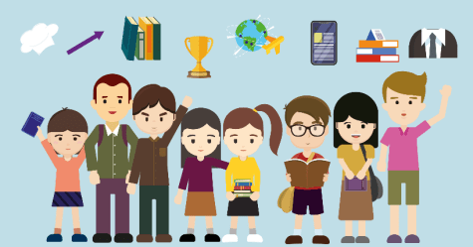

Joyful Reading
Appendix 6

Face and overcome difficulties positively
As the old saying goes, that’s the way the cookie crumbles. When we encounter difficulties and challenges, escape is not a correct solution. What we need to do is to face the difficulties with courage and strength. Problems can eventually be solved.

Here are some insightful quotes:

One can do it because they believe they can.

One defeats themselves far more than others do.

Action is the ladder of success,
the more you act, the higher you climb.

The surroundings are never perfect.
Negative people are controlled by the surroundings.
Positive people control the surroundings.
Don’t find excuses for failure;
find a way to success.

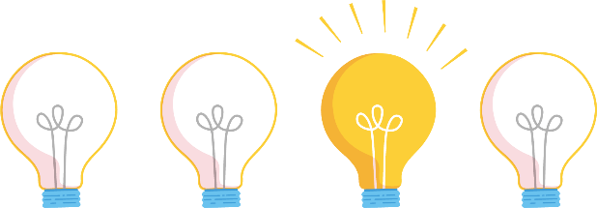

Sources: Famous quotes (undated)

Reflective question:
- How would you encourage yourself when you encounter something that fall short of your expectations?

References
中大教育研究所「香港學生能力國際評估中心」及中大香港亞太研究所青年研究中心（2019）。《學童身心靈健康評估計畫》。https://www.cpr.cuhk.edu.hk/resources/press/pdf/5cff69e31823c.pdf

平和基金（2017）。《香港人參與賭博活動情況2016研究報告》。https://www.hab.gov.hk/file_manager/tc/documents/policy_responsibilities/others/gambling_ex_2016.pdf

電子版香港法例。第480章《性別歧視條例》。 https://www.elegislation.gov.hk/hk/cap480!en?SEARCH_WITHIN_CAP_TXT=%E6%80%A7%E5%88%A5%E6%AD%A7%E8%A6%96%E6%A2%9D%E4%BE%8B&INDEX_CS=N&xpid=ID_1438403244314_001

平等機會委員會（2019）。《必須正視本港大學性騷擾問題》。https://www.eoc.org.hk/EOC/Upload/UserFiles/File/thingswedo/chn/twdpwm0105.htm

平等機會委員會（2020）。《性騷擾的法律定義》。

守網者（2022）。《網絡性愛•裸聊•性短訊》。
https://cyberdefender.hk/cybersex/

名人名言佳句（無日期）。《100句關於勵志的名人名言佳句》。https://mingyanjiaju.org/juzi/mingrenmingyan/2012/0324/287.html

家計會（2020）。《香港家庭計劃指導會網上資源性騷擾》。
https://www.famplan.org.hk/sexedu/zh/sexuality-education-resources/classroom-and-quiz/detail/SH01

投資者教育中心（2018）。《投資者教育中心調查顯示網上購物對消費者有利有弊》。
https://www.ifec.org.hk/web/tc/about-ifec/press-release/pr-20181101.page

東華三院（2020）。《不再迷『網』預防及治療網絡成癮服務計劃》。https://internetaddiction.tungwahcsd.org/

東華三院心瑜軒（2013）。《「網樂人」健康上網計劃》。
https://icapt.tungwahcsd.org/articles/poneteens

東華三院社會服務科青少年及家庭服務部（2009）。《青少年瀏覽網上色情資訊的現況及影響研究》。香港︰東華三院社會服務科青少年及家庭服務部。

香港01新聞（2020）。《吸毒青年受師父啟發 立志成影音導師 用鏡頭分享經歷》。
https://www.hk01.com/sns/article/507610?utm_source=01articlecopy&utm_medium=referral

香港01新聞（2020）。《新冠肺炎 上半年裸聊勒索案倍增12歲仔遭拍片被逼買千元點數卡》。
https://www.hk01.com/sns/article/519918?utm_source=01articlecopy&utm_medium=referral

香港01新聞（2022）。《復課即爆欺凌事件 小五生疑被迫「三跪九叩」道歉警拘兩同學》。
https://www.hk01.com/sns/article/767084?utm_source=01articlecopy&utm_medium=referral

香港01新聞（2022）。《毒品案趨年輕化 情傷少女吸大麻解憂：清醒後又跌返落地獄、好傻》。
https://www.hk01.com/sns/article/760155?utm_source=01articlecopy&utm_medium=referral

青年協會青年違法防治中心（2019）。《預防青少年墮入援交危機錦囊》。
https://ycpc.hkfyg.org.hk/2019/10/23/%E9%A0%90%E9%98%B2%E9%9D%92%E5%B0%91%E5%B9%B4%E5%A2%AE%E5%85%A5%E6%8F%B4%E4%BA%A4%E5%8D%B1%E6%A9%9F%E9%8C%A6%E5%9B%8A/

香港大學（2017）。《香港高小學生打機習慣調查2017》。
https://www.hku.hk/f/upload/16489/170620_attached_c.pdf

香港中文大學那打素護理學院（無日期）。《鑽出牛角尖》。
http://www.cadenza.hk/training/pdf/ws/CTP002_cur7_ws3_s1.pdf

香港家庭計劃指導會（2017）。《2016年青少年與性研究》。http://drive.famplan.org.hk/FPAHK/Research/2016YSS_Chi.pdf

香港特別行政區教育局（2016）。《健康管理與社會關懷知識增益系列⎯健康和社會關懷議題⎯成癮》。
https://www.edb.gov.hk/attachment/tc/curriculum-development/kla/technology-edu/resources/hmsc/17_Booklet_15D_C_Issues.pdf

香港特別行政區教育局（2020b）。《缺陷無罪 (防止校園欺凌)》。
https://www.edb.gov.hk/attachment/tc/curriculum-development/4-key-tasks/moral-civic/lea/ks3_4_6.doc

香港特別行政區教育局（2022d）。《價值觀教育：性教育的相關「生活事件」教案 裸聊誘惑》。
https://www.edb.gov.hk/tc/curriculum-development/4-key-tasks/moral-civic/sea/sea.html

香港特別行政區政府衛生署（沒有日期）。《e報告「使用互聯網及電子屏幕產品對健康的影響諮詢小組」報告》。https://www.studenthealth.gov.hk/tc_chi/internet/report/files/e_report.pdf

香港特別行政區政府衛生署學生健康服務（2009）。《彩橋》。第四十四期。https://www.studenthealth.gov.hk/tc_chi/newsletters/files/bridge44.pdf

香港警務處（2020）。《詳細罪案統計》。https://www.police.gov.hk/ppp_tc/09_statistics/csd.html

香港特別行政區警務處（2022）。《青少年罪行誌師長攻略》。
https://www.police.gov.hk/info/pr/ycpb/

香港特別行政區政府教育局課程發展處體育組（2020）。《體育（香港中學文憑）》。
https://cd1.edb.hkedcity.net/cd/pe/tc/nss%20pe/nss_lt/Part1_ch.pdf

香港特別行政區政府新聞處（2022）。《行政長官2022年施政報告》。
https://www.policyaddress.gov.hk/2022/public/pdf/measure/Policy-Measures-full-tc.pdf

香港特別行政區保安局禁毒處（2022）。《禁毒資訊》。
https://www.nd.gov.hk/tc/antidrug_resources.html

路德會青亮中心（賭博失調者輔導及治療中心）（2021）。《小機迷課金成癮 淪賭徒欠債百萬》。

https://sunshine-ccg.hklss.hk/hk/sunshine-news-and-events/sunshine-news/177-2021-08-10

星島日報（2020）。《留學青年涉非禮16歲女義工 邀睇三級片乘機摸胸》。https://hk.news.yahoo.com/%E7%95%99%E5%AD%B8%E9%9D%92%E5%B9%B4%E6%B6%89%E9%9D%9E%E7%A6%AE16%E6%AD%B2%E5%A5%B3%E7%BE%A9%E5%B7%A5-%E9%82%80%E7%9D%87%E4%B8%89%E7%B4%9A%E7%89%87%E4%B9%98%E6%A9%9F%E6%91%B8%E8%83%B8-051900565.html
馬銀春（2011）。《成功是折騰出來的》。中國：世界知識。

基督教聯合那打素社康服務情緒健康輔導中心（沒有日期）。《心理角度下看校園欺凌問題》。
http://www.ucep.org.hk/specialist_idea/detail.php?rec=14

壹讀（2016）。《青少年網絡成癮成因分析》。
https://read01.com/zh-hk/2PxPzP.html

黃瑩瑩（2019）。《解憂手冊》。香港：香港青年協會。

楊國樞（1986）。家庭因素與子女行為：臺灣研究的評析。《中華心理學刊》，28（1），7-28。

許韶玲、施香如（2013），《網路成癮是一種心理疾病嗎？》

COSH (2022). Being young is not an excuse for not quitting Montagut Chuen was diagnosed with nasopharyngeal cancer at 22.
https://quitters.smokefree.hk/story-04-en.html

Department of Health, the Government of the HKSAR (undated). e-report on Healthy Use of Internet and Electronic Screen Products.
https://www.studenthealth.gov.hk/english/internet/report/files/e_report.pdf

Dr. Kimberly Young (2011). Internet Addiction A Handbook and Guide to Evaluation and Treatment.

Education Bureau of the HKSAR (2015). Prevention of Sexual Harassment in Schools.
https://www.edb.gov.hk/en/sch-admin/admin/about-sch/sch-sexual-harassment-prevention/index.html

Education Bureau of the HKSAR (2017). Booklet 6A: Moral and Civic Education: Towards Values Education.
https://www.edb.gov.hk/attachment/tc/curriculum-development/major-level-of-edu/secondary/curriculum-guides-documents/SECG_booklet_6A_ch.pdf

Education Bureau of the HKSAR (2020a). Understanding Bullying.
https://www.edb.gov.hk/en/teacher/student-guidance-discipline-services/gd-resources/anti_bullying1/index.html

Education Bureau of the HKSAR (2020c).Say no to drugs.

Education Bureau of the HKSAR (2020d). Co-creating a Harmonious School - Stop Bullying Resource Package.
https://www.edb.gov.hk/attachment/en/teacher/student-guidance-discipline-services/gd-resources/anti-bullying/stopbullying_eng_final.pdf

Education Bureau of the HKSAR (2020e). Caring for Students and Helping them Get Back on the Right Track.
https://www.edb.gov.hk/attachment/tc/teacher/student-guidance-discipline-services/gd-resources/2021/20200902_EDBCM20083E.pdf

Education Bureau of the HKSAR (2022a). Intimacy Boundary.
https://www.edb.gov.hk/attachment/tc/curriculum-development/4-key-tasks/moral-civic/sea/SEA04_Chi_20151203.mp4

Education Bureau of the HKSAR (2022b). The Intimate Couple (Theme: Public Display of Affection).

Education Bureau of the HKSAR (2022c). Say no to compensated dating.
https://www.edb.gov.hk/attachment/tc/curriculum-development/4-key-tasks/moral-civic/lea/say%20no%20to%20compensated%20dating.pptx

Equal Opportunity Commission (2021). Learn the law, know your rights.
https://www.eoc.org.hk/compass/wp-content/uploads/2022/02/Understanding-Sexual-Harassment-ENG.pdf

Hong Kong Institute of Asia-Pacific Studies, The Chinese University of Hong Kong
and The Hong Kong Institute of Asia-Pacific Studies (2019). Health Behaviour in School-aged Children.

Hong Kong Jockey Club (2020). What is Problem Gambling?
https://www.hkjc.com/responsible-gambling/en/problem/index.aspx

Hong Kong Police Force (2020). Overall Crime and Violent Crime Situation.
https://www.police.gov.hk/ppp_en/09_statistics/csd.html

Hong Kong Police Force (2022). A chronicle of juvenile crimes – Strategies for teachers and parents.
https://www.police.gov.hk/info/pr/ycpb/

Information Services Department. the Government of the HKSAR (2009). 2022 Policy Address.
https://www.policyaddress.gov.hk/2022/public/pdf/policy/policy-full_en.pdf

Narcotics Division, the Government of the HKSAR (2022). Anti-drug information.
https://www.nd.gov.hk/en/antidrug_resources.html

Narcotics Division, the Government of the HKSAR (2022). Key message about Cannabidiol (CBD).
https://www.nd.gov.hk/en/

Physical Education Section, Curriculum Development Institute, Education Bureau, the Government of HKSAR (2020). Physical Education (HKDSE).
https://www.edb.gov.hk/en/curriculum-development/kla/pe/ss-pe-elective/hkdse_pe_ltp/index.html

Seligman, M. E. P. (1998). Learned optimism: How to change your mind and your life (2nd ed.). New York, NY: Pocket Books.

Seligman, M. E. P., Rashid, T., & Parks, A. C. (2006). Positive psychotherapy. American Psychologist, 61, 774-788.

Student Health Service, Department of Health, the Government of the HKSAR (2005). Bridge. Issue no.27.

Student Health Service, Department of Health, the Government of the HKSAR (2009). Bridge. Issue no.44.
https://www.studenthealth.gov.hk/english/newsletters/files/bridge44.pdf

Student Health Service, Department of Health, the Government of the HKSAR
(2020). Healthy living.
https://www.studenthealth.gov.hk/english/health/health_hl/health_hl_ahl.html

The Family Planning Association of Hong Kong (2017). Youth Sexuality Study 2016.
https://www.famplan.org.hk/files/media/press-release/2017/2016YSS_Eng.pdf

The Tung Wah Group of Hospitals (2020). Internet Addiction Prevention and Treatment Service.
https://internetaddiction.tungwahcsd.org/en/

The Tung Wah Groups of Hospital (2022). The Internet Addiction Test.

Tobacco Control Office, Department of Health, the Government of the HKSAR (2017). To be Stylish or out? It’s up to you smoking and youth.
https://www.taco.gov.hk/t/tc_chi/downloads/files/smoking_youth_english.pdf

World Health Organisation (1948). WHO definition of health.
https://www.who.int/about/frequently-asked-questions

World Health Organization (2020). Public health implications of excessive use of the Internet and other communication and gaming platforms.
https://www.who.int/news/item/13-09-2018-public-health-implications-of-excessive-use-of-the-internet-and-other-communication-and-gaming-platforms

Youth CLIC (2020). Sexual Offences.
https://www.youthclic.hk/zh/topic/sexual-offences/sexual-offences-unlawful-sexual-intercourse-with-a-girl-under-13-years-of-age/

